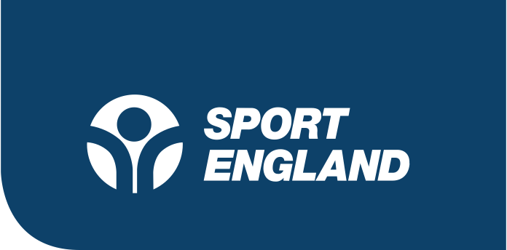

Press release

09:30 23 April 2020

Activity levels were at record high before COVID-19 pandemic

- Sport England’s Active Lives report shows that activity levels were on the rise before the Covid-19 pandemic and inactivity was falling.
- Greater numbers of women, older people, and people with a disability or long-term health condition were active, however inequalities linked to ethnicity and affluence remain.
- The power of sport and physical activity to support mental health and tackle loneliness is also revealed, with active people less likely to feel lonely and more likely to report higher mental wellbeing.

Activity levels in England were at their highest ever before the coronavirus outbreak - and levels of inactivity were falling across the country, Sport England’s Active Lives report, published today, shows.

Active Lives is the most comprehensive snapshot of the nation’s activity levels. The survey of 181,535 people, conducted before the coronavirus outbreak, paints a picture of improvement in the 12 months to November 2019, and reveals useful learnings that will help inform the sport and physical activity sector as it responds to the disruption caused by the pandemic.

The survey shows that 28.6m adults in England (63.3%) were active - which means meeting the Chief Medical Officer’s recommended 150 minutes of moderate intensity physical activity a week - an increase of 404,600 people on the previous twelve months.

At the other end of the spectrum, there were 159,500 fewer inactive adults, referring to those who are doing less than 30 minutes a week.

The report also provides more evidence on the wider benefits of playing sport and being physically active to mental health and loneliness, as figures show that people who are active are less likely to feel lonely and report higher levels of happiness. This applies to both sports volunteers and participants.

Increased activity levels were largely driven by increases in women, older adults aged 55+ and people with disabilities or long-term health conditions – all areas where Sport England has focused significant investment and campaigning in recent years. Sport England has invested in campaigns such as This Girl Can, which targets women, We are Undefeatable for people with long term health conditions and more recently it has been working with Demos on a home exercise radio show called 10 Today supporting the over 70s to be more active.

The latest survey also shows inequalities linked to ethnicity and affluence, while not rising, do remain, with people from ethnic backgrounds and people in lower socio-economic groups less likely to be active.

It also reveals a concerning drop in the activity levels of young people aged between 16 and 34, with those who are active in that age group falling by 265,100 people (1.7%) compared to the year before.

Inactivity among this age group has also increased by 176, 600 people (1.4%). This is particularly worrying when coupled with what the survey tells us about the benefits of activity in tackling loneliness because 16-24 year-olds are the most likely age group to say they always feel lonely.

Although patterns of activity levels during the ongoing pandemic and lockdown are not yet clear, there are risks that this period of time could both halt the growth we have seen in recent years and deepen existing inequalities – with habits and activity behaviours all significantly disrupted and sports at every level stopped altogether.

There is already evidence that the trend for people in lower socio-economic groups to be less active is continuing during the pandemic with additional research conducted by ComRes for Sport England revealing that people on low incomes are finding it harder than normal to be active at the moment.

Sport England CEO, Tim Hollingsworth said:

“That overall activity levels were at a record high across England at the end of last year is excellent news, particularly the strong growth among older adults, people with a disability and among those with long term health conditions. These are areas which Sport England has committed significant time, insight and investment into in recent years and it is encouraging that we were starting to see such growth there.

“However, behind the overall positive picture, there remain areas of real concern - not least the sobering reality that if you are well off you are far more likely to be active than if you are not, and the ongoing evidence of a significant ethnicity gap, where we are not seeing growth in activity levels among some ethnic groups.

“Added to this now is the unprecedented disruption the pandemic and lockdown is having on people's sport and activity habits and behaviours. The true nature of this, and its impact on the nation’s future activity and the ability of the sector to support that, is still unknown. But it is what anyone with an interest in sustaining the nation’s wellbeing, and the positive impact that sport can have on society, needs to start thinking about now. Because how we shape our collective response to this challenge will not only determine future participation levels, but also give us the opportunity fundamentally to address and reverse those inequalities.”

Other findings include:

Movement trends
- Walking was the most popular way for English adults to get active and is growing with 20.3m people getting active by walking for leisure (an increase of 1.2m people) and 15.3m walking for travel (an increase of 371,400 people)
- Fitness activities such as gym, weights and interval sessions, fitness classes, exercise machines and general training, were the third most popular way to be active, with 12.9m participants, although there was a drop in the numbers from the year before

Women
- The gender gap between men and women has reduced further. In the last twelve months 211,000 (0.7%) more women were active, reducing the gender gap to 210,900 (3.9%), down 145,200 (0.7%) from 2015 levels – 356,100 (4.6%)

Age
- 610,100 (2.8%) more older adults over 55 are active than twelve months ago. Walking is the most common activity, but others such as hill walking, combat sports and cycling for leisure and travel are up.
- Activity levels are decreasing for young people, with most sporting activities, running, swimming and fitness activities showing a decline.

Socio-economic groups
- People in lower socio-economic groups are 18% less likely to be active than those from the most affluent groups.
- There has been no change in activity levels for lower socio-economic groups since 2015.

Disability / long-term health conditions
- Activity levels are on the rise for people with a disability or long-term health condition with 4.5m (47.3%) active, compared to 4.2m (44.8%) twelve months ago, an increase of 258,100 (2.5%)

Ethnicity

- Activity levels for White British adults are showing a steady increase, but for most ethnic backgrounds there is an underlying flat trend.

Wider benefits of Sport
- There remains a positive association between physical activity levels and mental wellbeing with those who are active having higher levels of mental wellbeing.

Since this research was conducted, Sport England has commissioned a new, ongoing weekly tracker survey with ComRes to understand how COVID-19 is impacting how people feel about and take part in physical activity; a new consumer campaign Join the Movement to inspire and encourage people to #StayInWorkOut while adhering to government guidelines; and a multimillion pound package of support for organisations that help the nation stay active.

For more information about the report visit www.sportengland.org/activelivesapr20
For more on Sport England’s response to COVID-19 visit www.sportengland.org
-ENDS-

Notes for Editors
For further information and interview opportunities please contact: Jamie Harding, jamie.harding@sportengland.org / 0207 273 1593

About Sport England
Sport England is a public body and invests up to £300 million National Lottery and government money each year in projects and programmes that help people get active and play sport. It wants everyone in England, regardless of age, background, or level of ability, to feel able to engage in sport and physical activity. That’s why a lot of its work is specifically focused on helping people who do no, or very little, physical activity and groups who are typically less active - like women, disabled people and people on lower incomes.

About Active Lives
Active Lives is a national survey conducted by Ipsos MORI on behalf of Sport England. Launched in 2015 it is a national statistic measuring physical activity in its broadest sense and includes activities such as walking, cycling for travel and dance as well as traditional sport alone to reflect the Government’s Strategy Sporting Future: A New Strategy for an Active Nation. The Active Lives Adult Survey is a push-to-web survey sent out to a randomly selected sample of households across England. 181,535 people aged 16+ completed the survey between November 2018 and November 2019. Confidence intervals apply to the percentages and population estimates presented in the report and report tables. Confidence intervals for the measures presented in the report can be found in the linked report tables. Confidence intervals indicate that if repeated samples were taken and confidence intervals computed for each sample, 95% of the intervals would contain the value. To find out more about Active Lives and see the full results in full, go to www.sportengland.org/activelivesapr20

