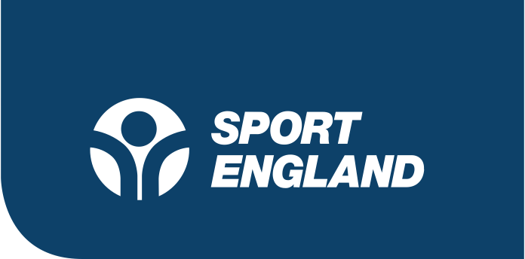

Press release: for immediate release

21 May 2020

Surge in appreciation for the benefits of exercise and activity during lockdown across England

- During Mental Health Awareness week, new research shows that 63% of people say that they are using exercise to manage their mental health during the pandemic
- Cycling and walking are England's most popular activities, with participation levels significantly increasing over the course of lockdown.

Living in lockdown has brought a much greater appreciation for the benefits of being active, a rolling six-week survey of physical activity behaviour and attitudes run by Sport England shows.
While the pandemic has affected how people get active, the government focus on getting outside for exercise every day has helped to fuel new habits and behaviours, from families getting active together; to those taking their daily allowance of outdoor exercise in nearby greenspaces; to those walking or cycling to the high street for essentials.

Lockdown has also brought a stark appreciation of how activity supports people’s mental health, with an average of 63% of respondents stating they get active now to aid their mental health.

Walking (63%), home exercise (43%) and cycling (13%) are among the activities that have seen recent peaks of participation during the pandemic – compared to 59%, 44% and 8% respectively in week 1, while visiting the gym is the most popular activity that people are looking forward to resuming when re-open (14%). Prior to the pandemic, walking was the most popular activity in England with 28.02m walking for leisure or travel at least twice a month.

New habits, but the same inequalities

While attitudes and intentions to get active are positive, inequalities related to those from lower-socio economic groups (LSEG), older people, BAME groups and women have been exacerbated.

The gender gap remains, with more men doing the recommended amount of weekly exercise (35% of men compared to 30% of women) of 5 x 30 minutes, while more women are doing less exercise than usual compared to men (40% compared to 36%).

23% of people with long-standing health conditions or illnesses are doing 5 x 30 minutes of activity a week compared to 35% of those with no long-standing health condition or illness.

People in C2DE groups are more likely to be on a lower income, be key workers, be accessing food banks, or have lost their jobs. In the ABC1 groups, 39% are doing more activity than usual, whereas in C2DE groups, only 27% are doing more than usual.

In order to reach groups that are finding it harder to be active, Sport England has launched a £20m Tackling Inequalities Fund, backed by National Lottery funding that will work with specific partners and organisations to ensure inequalities do not become entrenched during this period.

Sport England also launched the Join the Movement campaign, backed by a TV and radio ad, and a website www.stayinworkout.org offering free workout ideas for in the home and outside – including the newly launched Couch to 5K app, and the Active 10 walking app.

Director of Insight for Sport England, Lisa O’Keefe said:

“It has been great to see people finding ways to be active and see that more and more people are talking about exercise being part of the approach to managing both their physical and mental health.

“Undoubtedly the current period has been hugely difficult for both the sport and physical activity sector and the general public, yet people are finding a new appreciation for moving more – whether it’s at home or out walking or cycling. The pandemic has changed the way we engage with activity and it will continue to do so as we begin the gradual journey towards a new normal as more sport and leisure facilities open up.

“It’s important that everyone – from whatever background, age, gender or ability, is able to access those benefits and at Sport England we are looking forward to working with the many organisations who share our desire to help the nation move more while ensuring no one gets left behind.

Professor Greg Whyte OBE, ukactive Scientific Advisory Board member, said:

“COVID-19 has threatened both our mental and physical health, but physical activity has helped many people to fight back. As well as making us feel more positive, exercise has a crucial role to play in improving the body’s resilience. Not only can exercise reduce infection, it can dampen the deleterious response to infection and play an integral role in the rehabilitation of people recovering from the virus.

“The challenge we now face as a society is to harness the value of physical activity in both prevention and rehabilitation, and we must make sure that everybody can benefit, regardless of their background. We must look at our health and fitness providers as an essential public service, providing immeasurable support to our NHS at a time when it’s needed most.”

-ENDS-

Notes for Editors

Interviews with case studies available upon request:

Rajinder Singh Harzall, aka the ‘Skipping Sikh’, 73 who stars in Sport England’s Join the Movement TV advert. Rajinder started skipping at the start of lockdown as a way to keep fit as he could no longer take part in his weekly parkrun. His daughter tweeted a video of him skipping, which went viral overnight. This led Rajinder to compete in skipping challenges where he’s so far raised over £13,000 for the NHS. He is passionate about exercising with his family in accessible ways that they can all enjoy.

Marjorie Barnes, 63. Marjorie is registered disabled with a severe back problem and scoliosis in her lower spine. Despite using a walking stick and suffering from mobility issues, she is still passionate about keeping active. When the coronavirus pandemic first started, Marjorie stopped being as active as she once was. But she learnt to embrace online classes during lockdown and is now out walking again since restrictions have been loosened. She said:

“My mother sadly passed away at the beginning of lockdown and I had a fall. Being active felt really difficult, although I managed the occasional long walk. Getting active has really changed my life and these past few weeks not being able to meet up with friends, walk and talk, has made me feel increasingly stressed, low and a bit isolated. Now that I can walk with one other person, my mood has lifted and feel like I have my confidence back. Being active is something we can all do. I never ever thought I would be a long-distance walker, but there is something for all of us. I have made so many new friends and feel like I have my freedom back. I want everyone to be able to experience this.”

Dr Kishan Bodalia, 25. Kishan is a Junior Doctor working on the COVID-19 frontline at a Birmingham hospital. He is passionate about keeping active and fit, believing it is just as important for mental wellbeing as it is for physical. Kishan recently appeared in the advert for Sport England’s Join the Movement campaign, after a video of him dancing on his hospital ward went viral on TikTok. Kishan also runs NHS Sessions, where he DJs and dances in his scrubs to cheer up the nation, which has received backing from BBC Radio 1, global DJ Cuppy, DJ Kristian Nairn (from Game of Thrones) and more.

For further information and interview opportunities please contact: Jamie Harding: jamie.harding@sportengland.org / 0207 273 1593

Each week’s results come from interviews with c. 2,000 adults (16+) in England. Data has been weighted to be representative of adults in England by age, gender, region and social grade, including those with children ages under 16 in their household.

The most recent data point Sport England survey, carried out by Savanta ComRes from 8th to 11th May 2020 (wave 6 / week 6), surveyed 2,002 English adults (16+) on their physical activity attitudes and behaviours during the COVID-19 pandemic. Research began on April 3-6 with wave one / week one.

Savanta ComRes is a member of the British Polling Council and abides by its rules.

Full tables at: http://www.comresglobal.com/polls/sport-england-survey-into-adult-physical-activity-attitudes-and-behaviour/

About Sport England

Sport England is a public body and invests up to £300 million National Lottery and government money each year in projects and programmes that help people get active and play sport. It wants everyone in England, regardless of age, background, or level of ability, to feel able to engage in sport and physical activity. That’s why a lot of its work is specifically focused on helping people who do no, or very little, physical activity and groups who are typically less active - like women, disabled people and people on lower incomes.

