

Active Lives
Children and Young People

Year 3-6

Questionnaire Summary 2026-27

Introduction
This document has been designed to summarise the content of the Active Lives Children and Young People questionnaire for children in Years 3 to 6. Please note that the online questionnaire has been designed to be engaging for children to complete and therefore questions are not displayed in the same format as shown below.
Background information is highlighted in blue italic text for your information. This is not displayed to children.
Some questions will be displayed only to children in Year 5 and 6 classes. These are shown in red text.

Question 1

Have you got headphones to use now?
- Yes
- No

Question 2

Which school year are you in?
- Year 3
- Year 4
- Year 5
- Year 6

Question 3

Where are you doing this survey?
- At school
- At home
- Somewhere else
- Prefer not to say

Year 5-6 only

Question 4

Since [current month] last year, have you been to see any live sporting events?
ü Please include all matches, races and competitions, including professional sport and watching friends and family compete.
X Please do not include any events that you took part in yourself, or events you watched on TV.
- Yes
- No
- Can’t remember

Year 5-6 only

Question 5
Asked if ‘Yes’ was selected at Question 3.

How many live sporting events have you been to see since [current month] last year?
ü Please include all matches, races and competitions, including professional sport and watching friends and family compete.
X Please do not include any events that you took part in yourself, or events you watched on TV.
- One
- Two
- Three or more

Question 6
Children should be encouraged only to think about the last week for this question. Some children might be tempted to select everything they have ever done but this would be incorrect and may also make subsequent questions more complex for them to answer.

Which of these have you done anywhere in the last seven days, since last [current day of the week]?
Include
- At school (PE or other lessons, break time, lunch time)
- At home or in the garden
- At clubs
- Somewhere else

Please choose everything you did.

The appearance and layout of the answers to this question and the next one will depend on which of the 2 versions of the questionnaire you are using.
- Walking to get to school or other places such as friends’ houses or a park
- Going on a walk (includes walking a dog or hiking)
- Riding a scooter for fun or to get to places like school, friends’ houses or a park
- Cycling to get to school or other places such as friends’ houses or a park
- Cycling/riding a bike for fun or fitness (includes BMX or mountain biking)
- Dancing (including online or TV led e.g. TikTok dances, ballet, tap, street etc)
- Kicking a ball about
- Skateboarding, roller skating/blading
- Trampolining (including in a garden, at a trampoline centre, or as part of a club)
- Throwing and catching games, such as piggy in the middle and frisbee
- Playing it, tag, chase, sardines or other running games
- Climbing or swinging in the playground, garden or park
- Skipping or hopscotch
- Swimming
- Gym or fitness (fitness/online class e.g. push-ups, sit-ups, or yoga, or using exercise machines e.g. rowing machine, exercise bike, running machine)
- Football
- Netball
- Hockey
- Cricket
- Rugby (including tag rugby)
- Baseball, softball
- Rounders
- Basketball
- Dodgeball, benchball
- Table tennis/ping pong
- Badminton
- Tennis
- Gymnastics
- Acrobatics including aerial, aerial hoop and acro
- Cheerleading
- Running, jogging, cross-country
- The daily mile, active mile, or other regular run done with your class at school
- Sports day events
- Horse riding
- Judo, karate, taekwondo and other martial arts
- Boxing
- Climbing (including indoors)
- Ice skating
- Water sports (canoeing, kayaking, sailing, rowing, surfing)
- If you did any other sports or exercise, please tell us what you did in the boxes below
- __________________
- __________________
- __________________
- __________________
- None of these

Question 7
Children who selected at least one activity at Question 6 are now asked on which school weekdays they did each of the activities, firstly at school in PE or other lessons, during breaks or lunch times, then which they did before or after school, including in school clubs, at weekends or in the holidays:
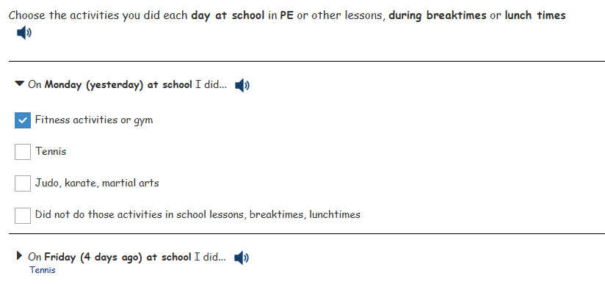

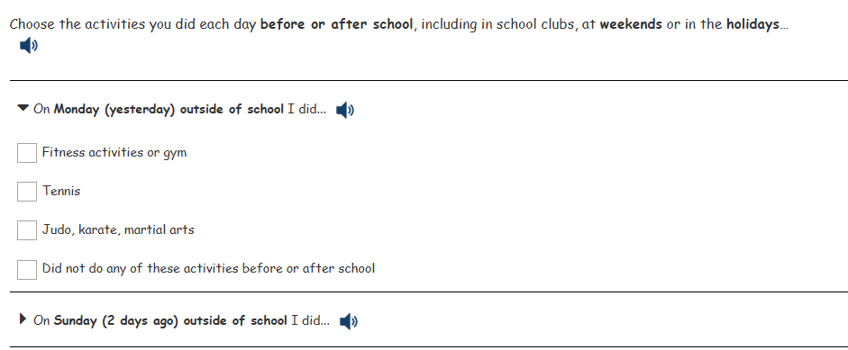

Question 8
Children who say that they did any activities (excluding walking to or from school, or cycling to or from school) outside school hours, will be asked this question once for each activity.

How long did you [activity] for on [day of the week]?
As an example, if a child fills in the grid to show they played rugby on Friday, seven days ago, this question will ask ‘. How long did you play rugby for on Monday, yesterday, before or after school?”
- Less than 10 minutes
- About 15 minutes
- About 30 minutes
- About 45 minutes
- One hour
- More than an hour
- Don’t know

The indoors / outdoors questions will not be asked in relation to:
- Walking to get to school or other places
- Going on a walk
- Riding a scooter
- Cycling to get to school or other places
- Climbing or swinging in the playground, garden or park
- Cycling for fun
- Sports day
- Field athletics
- Rounders
- Dancing
- Kicking a ball about
- Swimming
- Football
- Hockey
- Rugby
- Running/jogging
- Gym or fitness
- Horse riding
- Martial arts
- Boxing

Question 9
Children who said that they walked to or from school on any day will be asked this question.

How long does it usually take you to walk to / from school?
- Less than 10 minutes
- About 15 minutes
- About 30 minutes
- About 45 minutes
- One hour
- More than an hour
- Don’t know

Question 10
Children who said that they cycled to or from school on any day will be asked this question.

How long does it usually take you to cycle to / from school?
- Less than 10 minutes
- About 15 minutes
- About 30 minutes
- About 45 minutes
- One hour
- More than an hour
- Don’t know

Questions 11&12
Children who selected at least one activity at Question 5 and gave a time slot in the grid will be asked the following questions for each activity they selected. Both questions appear on the same screen.
Some activities will have the intensity assumed and therefore these questions will not be asked.

When you [activity], did it make you breathe faster than sitting down reading?
- Yes
- No

When you [activity], did it make you hot or tired?
- Yes
- No

Questions 13 to 16
These questions are asked to all children and appear on the same screen. Children should be encouraged to think about all types of physical activity rather than a specific sport or type of exercise when answering these questions.

We would now like you to think about all types of exercise and sport.

How much do you agree or disagree with the following statements?

I enjoy taking part in exercise and sports.
- Strongly agree
- Agree
- Disagree
- Strongly disagree
- Can’t say

I feel confident when I exercise and play sports.
- Strongly agree
- Agree
- Disagree
- Strongly disagree
- Can’t say

I find exercise and sports easy.
- Strongly agree
- Agree
- Disagree
- Strongly disagree
- Can’t say

I understand why exercise and sports are good for me.
- Strongly agree
- Agree
- Disagree
- Strongly disagree
- Can’t say

Questions 17 to 19
These questions are asked to all children and appear on the same screen.

I work well with other children when doing exercise and sports.
- Strongly agree
- Agree
- Disagree
- Strongly disagree
- Can’t say

Taking part in exercise and sports matters to me.
- Strongly agree
- Agree
- Disagree
- Strongly disagree
- Can’t say

Exercising and doing sports makes me feel better about myself.
- Strongly agree
- Agree
- Disagree
- Strongly disagree
- Can’t say

Question 20

The adults who run my exercise and sports activities listen to me when I have an idea.
- Strongly agree
- Agree
- Disagree
- Strongly disagree
- Can’t say

Question 21

Can you swim?
- Yes
- No

Question 22
Asked if pupil answered ‘Yes’ to Question 23.

Can you swim a length of a swimming pool (25 metres) without stopping?
- Yes
- No

Question 23

Can you stay in one place in the pool and keep your head above the water without holding onto the side or a float, and without touching the bottom of the pool? This is sometimes called treading water.
- Yes
- No

Question 24

Imagine that you fall into a large lake. The lake is deep and you can’t touch the bottom. You have all your clothes on, and you are about five metres away from the land (this is about the length of a large car). Could you get back to the land without someone helping you?
- Yes
- No

Question 25
Year 5-6 only

Can you ride a bike?
- Yes, without stabilisers
- Yes, with stabilisers
- Yes, an adaptive bike or adaptive trike for children with disabilities or special needs
- No
- Don’t know

Question 26
Year 5-6 only

Since [current month] last year, have you volunteered, or given your time to do any of the following activities?

Think only about when you do them to help with sports, exercise or dance.
Please choose everything you have done
- Raised money for sports or dance at school or a club
- Been a ‘sports leader’ or ‘sports ambassador’
- Helped with setting up or clearing away
- Helped with refreshments (food or drink)
- Given any other help. Please tell us what you did:
__________________
- No, have not done any of these activities since [current month] last year

Question 27

Overall, how happy did you feel yesterday?
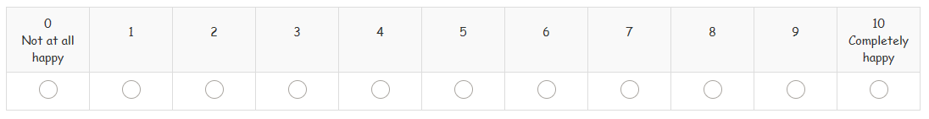

Question 28
For this question children should be encouraged to think about all activities, not just sport and physical activity. Icons are shown to help illustrate this.
Thinking about all the things you do at school and at home, how much do you agree or disagree with the following statement:

If I find something difficult, I keep trying until I can do it.


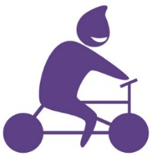
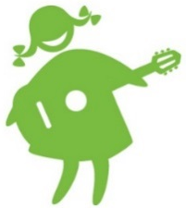
- Strongly agree
- Agree
- Disagree
- Strongly disagree
- Can’t say

Question 29

How much do you feel you can trust people who are your age?
- I can trust them a lot
- I can trust them a bit
- I can’t trust them very much
- I can’t trust them at all
- Can’t say

Question 30
How often do you feel you belong at school? Belong means feeling that you fit in at school
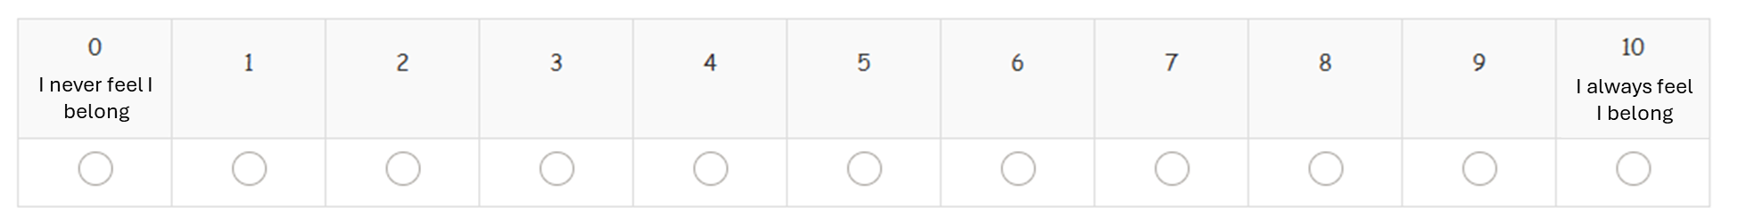

Question 31
We now have some final questions about you.

Are you a…
- Girl
- Boy
- Prefer not to say

Question 32

How old are you?
- 7
- 8
- 9
- 10
- 11

Question 33

Which one of these best describes your background or race?
- White (British or English)
- White (not British or English)
- Mixed e.g. White and Black , White and Asian
- Asian or British Asian
- Black or Black British
- Another group (please type in)
- Prefer not to say

Question 34

Do you have a disability, special need or medical need (e.g. autism, dyslexia, or asthma), which makes it difficult for you to do any of these things?
- Yes
- No
- Don’t know
- Prefer not to say

- Concentrating and paying attention (includes ADHD)
- How you behave in a way which makes life difficult (includes anger problems)
- Reading or writing (includes dyslexia)
- Using numbers (e.g. putting numbers the wrong way around)
- Difficulty learning or understanding new things (includes finding it hard to remember things)
- How you feel (including feeling anxious or depressed)
- Co-ordination (includes balance problems
- Moving around including walking and running
- Using your hands for writing or to pick things up (includes difficulty holding a pen)
- Seeing and using your eyes (includes colour blindness)
- Hearing and using your ears
- Speaking and communicating
- Breathing (includes asthma)
- Gives you pain (e.g. hypermobility)
- Affects your health for a long time (includes conditions such as diabetes)
- Something else you have difficulty with because of your disability, special need or illness

Question 35
Asked if answered ‘Yes’ to Question 36.

Which of these do you have difficulty with because of your disability, special need or medical need?
Please tick all the boxes that apply
- Concentrating and paying attention (includes ADHD)
- How you behave in a way which makes life difficult (includes anger problems)
- Reading or writing (includes dyslexia)
- Using numbers (e.g. putting numbers the wrong way around)
- Difficulty learning or understanding new things (includes finding it hard to remember things)
- How you feel (including feeling anxious or depressed)
- Co-ordination (includes balance problems
- Moving around including walking and running
- Using your hands for writing or to pick things up (includes difficulty holding a pen)
- Seeing and using your eyes (includes colour blindness)
- Hearing and using your ears
- Speaking and communicating
- Breathing (includes asthma)
- Gives you pain (e.g. hypermobility)
- Affects your health for a long time (includes conditions such as diabetes)
- Something else you have difficulty with because of your disability, special need or illness
- None of these
- Don’t know
- Prefer not to say

Question 36
Asked if answered any response bar ‘None of these, ‘Don’t know’ or ‘Prefer not to say’ to Question 37.

Does this disability, special need or medical need have a big effect on your life?
- Yes
- No
- Don’t know
- Prefer not to say

Question 37
Asked if answered any response bar ‘None of these, ‘Don’t know’ or ‘Prefer not to say’ to Question 37.

Do you think this disability, special need or medical need will last for a year or more?
- Yes
- No
- Don’t know
- Prefer not to say

Question 38
If a child spends their time living in different homes with different parents or carers, they should answer these questions thinking about the home they will stay at tonight.
We would now like to ask you some questions to understand more about your home and your family.
These questions will help us find out more about what affects how much sport and exercise children and young people do.

Does your family own a car, van or truck?
- No
- Yes, one
- Yes, two or more
- Prefer not to say

Question 39

Do you have your own bedroom for yourself?
- Yes
- No
- Prefer not to say

Question 40

How many computers does your family own (including laptops and tablets/iPads, but NOT including game consoles and smartphones)?
- None
- One
- Two
- More than two
- Prefer not to say

Question 41

How many times did you and your family travel out of England for a holiday last year?
- None
- Once
- Twice
- More than twice
- Prefer not to say

Question 42

How many bathrooms are in your home?
- None
- One
- Two
- More than two
- Prefer not to say

Question 43

Does your family have a dishwasher at home?
- Yes
- No
- Prefer not to say

Final screen
Pupils’ answers are automatically submitted. Once they reach this screen they can close the browser.

Thank you! That is the end of the survey.
If you have questions or are worried about anything in the survey, or anything else in your life the first person to talk to is a parent, other family member or someone else you trust, if you feel able to.
If you want more information or someone else to talk to there are some ideas below.
It is absolutely fine if you don’t need or want to talk to someone – we are providing this to everyone who takes part. None of the organisations listed will know that you took part in the survey, nor will they get in touch with you.
NHS: www.nhs.uk
This site helps you make choices about your health, exercise and healthy eating and has information on finding and using NHS services.
For advice and information on being physically active please visit: https://www.nhs.uk/live-well/exercise/physical-activity-guidelines-children-and-young-people/
CHILDLINE: 0800 11 11
A confidential and free helpline which will not appear on a phone bill. You can also go online for a 1-2-1 instant messenger chat with someone who is there to listen and support you at: www.childline.org.uk

