

Active Lives
Children and Young People

Parent

Questionnaire Summary 2026-27

Introduction
This document has been created to summarise the content of the Active Lives Children and Young People questionnaire for parents of children in Years 1 to 2.
Additional information is highlighted in blue italic text for your information. This is not displayed to parents.

Homepage
On entering the URL, parents will see the following screen.
They should select ‘Next’ to continue.
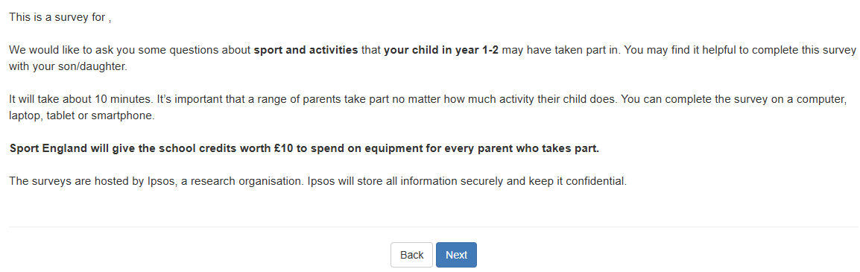
Parents are then informed of an audio feature
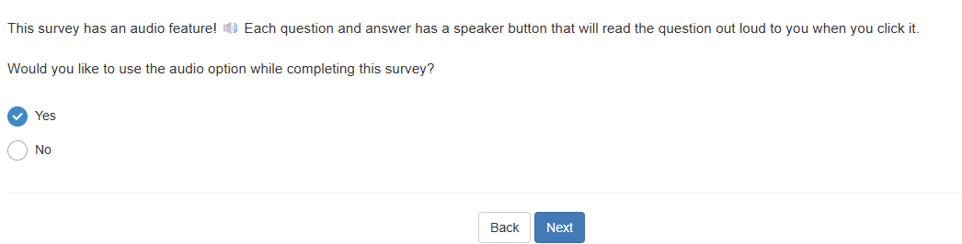

Question 1

Is your child a…
If you have more than one child in Year 1 or 2 please complete this survey about the child who is taking part in the survey with their class.
If you have more than one child completing the survey with their class:
- We would like you to complete this survey once for each child
- If you are only able to complete the survey once, please complete the questionnaire about the child whose name starts with the letter earliest in the alphabet, or the second letter if they share the same initial
- Boy
- Girl

Question 2

Which school year is your child in?
- Year 1
- Year 2

Question 3

Which of these has your child done anywhere in the last seven days, since last [current day of the week]?
Please select all that apply
- Walking to get to school or other places such as friends’ houses or a park
- Going on a walk (includes walking a dog or hiking)
- Riding a scooter for fun or to get to places like school, friends’ houses or a park
- Cycling to get to school or other places such as friends’ houses or a park
- Cycling/riding a bike for fun or fitness (includes BMX or mountain biking)
- Dancing (including online or TV led e.g. TikTok dances, ballet, tap, street etc)
- Kicking a ball about
- Skateboarding, roller skating/blading
- Trampolining (including in a garden, at a trampoline centre, or as part of a club)
- Frisbee, throwing and catching (including piggy in the middle) or skipping
- Playing it, tag, chase, sardines or other running games
- Climbing or swinging in the playground, garden or park
- Swimming
- Gym or fitness (fitness/online class e.g. push-ups, sit-ups, or yoga, or using exercise machines e.g. rowing machine, exercise bike, running machine)
- Football
- Netball
- Hockey
- Cricket
- Rugby (including tag rugby)
- Baseball, softball
- Rounders
- Basketball
- Dodgeball, benchball
- Table tennis/ping pong
- Badminton
- Tennis
- Gymnastics
- Acrobatics including aerial, aerial hoop and acro
- Cheerleading
- Running, jogging, cross-country
- The daily mile, active mile, or other regular run done with your class at school
- Sports day events
- Horse riding
- Judo, karate, taekwondo and other martial arts
- Boxing
- Climbing (including indoors)
- Ice skating
- Water sports (canoeing, kayaking, sailing, rowing, surfing)
- If you did any other sports or exercise, please tell us what you did in the boxes below
- __________________
- __________________
- __________________
- __________________
- None of these

Question 4
Parents who selected at least one activity at Question 3 are now shown a grid with the activities they selected on the left-hand side and school weekdays across the top. For example:
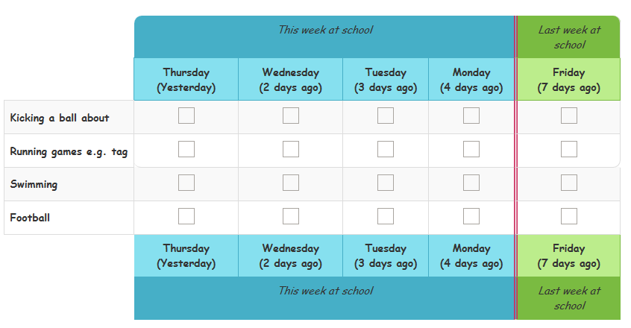
If parents select a large number of activities, they may see separate grids showing groups of activities.

Choose the days your child did each activity at school in PE or other lessons, during breaktimes or lunch times
You may find it helpful to complete this question with your child.

Question 5
Parents who selected at least one activity at Question 3 are now shown a second grid with the activities they selected on the left-hand side and all seven days of the week across the top. For example:
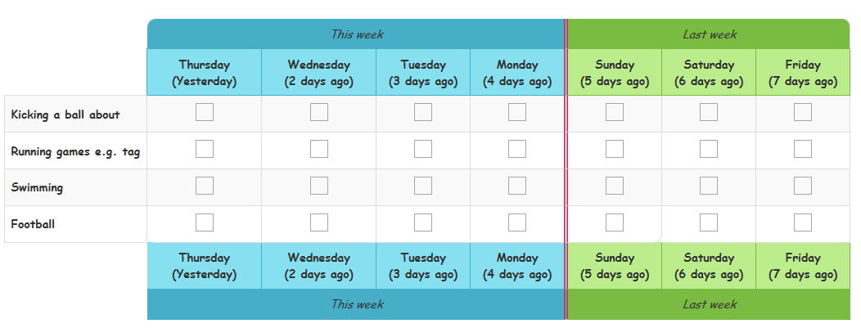

Choose the days your child did each activity before or after school, including school clubs, weekends or holidays

Question 6
Asked to parents who choose one activity in Question 3 but did not enter it on the grid

You told us that your child [activity] in the last seven days, but you did not tell us when.

For each activity, please tell us whether this is because your child did the activity but you are not sure when, or because your child did not actually do the activity.
- Your child did [activity], but you are not sure when in the last 7 days
- Your child did not do [activity] in the last 7 days

Question 7
Parents who say that their child did activities outside school hours, will be asked this question once for each activity.

You told us that on [day of the week], [X days ago], your child [activity] outside normal school hours.

How long did your child [activity] for?
- Less than 10 minutes
- About 15 minutes
- About 30 minutes
- About 45 minutes
- One hour
- More than an hour
- Cannot give an estimate

Question 8
Parents who said that their child walked to or from school on any day will be asked this question.

How long does it usually take your child to walk to school?
- Less than 10 minutes
- Less than half an hour
- About half an hour
- About three-quarters of an hour
- One hour
- More than an hour
- Cannot give an estimate

Question 9
Parents who said that their child cycled to or from school on any day will be asked this question.

How long does it usually take your child to cycle to school?
- Less than 10 minutes
- Less than half an hour
- About half an hour
- About three-quarters of an hour
- One hour
- More than an hour
- Cannot give an estimate

Question 10

Can your child swim?
- Yes
- No

Question 11
Asked if parent answered ‘Yes’ to Question 11.

Can your child swim a length of a swimming pool (25 metres) without stopping?
- Yes
- No

Question 12

Can your child tread water? This means staying in one place in the pool and keep their head above the water without holding onto the side or a float, without touching the bottom of the pool and without being held by someone.
- Yes
- No

Question 13
We now have some final questions about your child.

How old is your child?
- 5
- 6
- 7

Question 14

When is your child’s birthday? Please tell us the day and the month.
This question is asked so that your answers can be linked with answers your child has given in the survey using date of birth and gender. Your answers provide information on the activities your child does and your child’s answers tell us about their attitudes to activity.
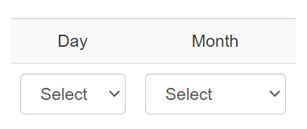

Question 15

What is your child’s ethnic group?
White
- English/Welsh/Scottish/Northern Irish/British
- Irish
- Gypsy or Irish Traveller
- Any other White background

Mixed/Multiple ethnic groups
- White and Black Caribbean
- White and Black African
- White and Asian
- Any other Mixed/Multiple ethnic background

Asian/Asian British
- Indian
- Pakistani
- Bangladeshi
- Chinese
- Any other Asian background

Black/African/Caribbean/Black British
- African
- Caribbean
- Any other Black/African/Caribbean background

Other ethnic group
- Arab
- Any other ethnic group

- Prefer not to say

Question 16

Does your child have a disability, special need or illness (e.g. autism, dyslexia, or asthma), which makes it difficult for them to do any of these things?
- Yes
- No
- Don’t know
- Prefer not to say

- Concentrating and paying attention (includes ADHD)
- How they behave in a way which makes life difficult (includes anger problems)
- Reading or writing (includes dyslexia)
- Using numbers (e.g. putting numbers the wrong way around)
- Difficulty learning or understanding new things (includes finding it hard to remember things)
- How they feel [and their mental health] (including feeling anxious or depressed)
- Co-ordination (includes balance problems
- Moving around including walking and running
- Using their hands for writing or to pick things up (includes difficulty holding a pen)
- Seeing and using their eyes (includes colour blindness)
- Hearing and using their ears
- Speaking and communicating
- Breathing (includes asthma)
- Gives them pain (e.g. hypermobility)
- Affects their health for a long time (includes conditions such as diabetes)
- Something else they have difficulty with because of their disability, special need or illness

Question 17
Asked if parent answered ‘Yes’ to Question 17.

Which of these do they have difficulty with because of their disability, special need or illness?
Please tick all the boxes that apply
- Concentrating and paying attention (includes ADHD)
- How they behave in a way which makes life difficult (includes anger problems)
- Reading or writing (includes dyslexia)
- Using numbers (e.g. putting numbers the wrong way around)
- Difficulty learning or understanding new things (includes finding it hard to remember things)
- How they feel [and their mental health] (including feeling anxious or depressed)
- Co-ordination (includes balance problems
- Moving around including walking and running
- Using their hands for writing or to pick things up (includes difficulty holding a pen)
- Seeing and using their eyes (includes colour blindness)
- Hearing and using their ears
- Speaking and communicating
- Breathing (includes asthma)
- Gives them pain (e.g. hypermobility)
- Affects their health for a long time (includes conditions such as diabetes)
- Something else they have difficulty with because of their disability, special need or illness
- None of these
- Don’t know
- Prefer not to say

Question 18
Asked if answered any response bar ‘None of these, ‘Don’t know’ or ‘Prefer not to say’ to Question 18.

Does this disability, special need or illness have a big effect on their life?
- Yes
- No
- Don’t know
- Prefer not to say

Question 19
Asked if answered any response bar ‘None of these, ‘Don’t know’ or ‘Prefer not to say’ to Question 18.

Do you think this disability, special need or illness will last for a year or more?
- Yes
- No
- Don’t know
- Prefer not to say

We would now like to ask your some questions to understand more about you, your home and your family.
These questions are not related to sport or physical activity but help us understand how wider factors might impact on children and young people’s engagement in sport and physical activity. Questions are designed to be answered by all age groups: parents, children and young people.

Question 20

Does your family own a car, van or truck?
- No
- Yes, one
- Yes, two or more
- Prefer not to say

Question 21

Does your child have their own bedroom for themself?
- Yes
- No
- Prefer not to say

Question 22

How many computers does your family own (including laptops and tablets/iPads, but NOT including game consoles and smartphones)?
- None
- One
- Two
- More than two
- Prefer not to say

Question 23

How many times did you and your family travel out of England for a holiday last year?
- None
- Once
- Twice
- More than twice
- Prefer not to say

Question 24

How many bathrooms (room with a shower/bath or both) are in your home?
- None
- One
- Two
- More than two
- Prefer not to say

Question 25

Does your family have a dishwasher at home?
- Yes
- No
- Prefer not to say

Question 26

As you completed the survey, did you involve your child at any point, yo help you answer the questions?
- Yes
- No

Final screen
Answers are automatically submitted. Once parents reach this screen they can close the browser.

Thank you! That is the end of the survey.
Below is some information which you may find useful.
NHS: www.nhs.uk
This site helps you make choices about your health, from lifestyle decisions about things like exercise and healthy eating, through the practical aspects of finding and using NHS services.
For advice and information on being physically active please visit:
https://www.nhs.uk/live-well/exercise/physical-activity-guidelines-children-and-young-people/ (Children and young people)
https://www.nhs.uk/live-well/exercise/ (Adults)

