

Active Lives
Children and Young People

Year 7-11

Questionnaire Summary 2026-27

Introduction
This document has been designed to summarise the content of the Active Lives Children and Young People questionnaire for pupils in Years 7 to 11. Please note that the online questionnaire has been designed to be engaging for young people to complete and therefore questions are not displayed in the same format as shown below.
Background information is highlighted in blue text for your information. This is not displayed to pupils.

Homepage
On entering the URL, Year 7 to 11 pupils will see the following screen. They should select ‘Next’ to continue.
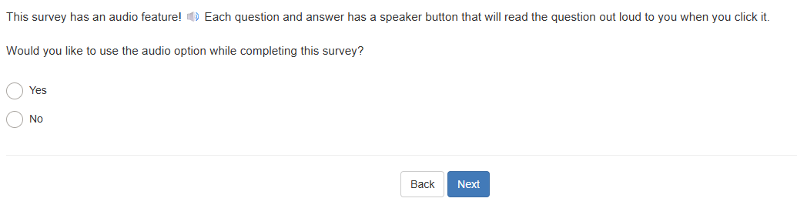
If respond ‘No’ to opening question
You can choose whether or not to take part. You have chosen not to start the survey. If you answered no by mistake click ‘back’ to go back to the previous question and start the survey now. If you would like to take part later you can go to the URL and start again when you want to. If you do not want to take part please select next and the survey will end.

Question 1

Where are you doing this survey?
- At school
- At home
- Somewhere else
- Prefer not to say

Question 2

Which school year are you in?
- Year 7
- Year 8
- Year 9
- Year 10
- Year 11

Question 3

Since [current month] last year, have you been to see any live sporting events?
ü Please include all matches, races and competitions, including professional sport and watching friends and family compete.
X Please do not include any events that you took part in yourself, or events you watched on TV.
- Yes
- No
- Can’t remember

Question 4
Asked if ‘Yes’ was selected at Question 3.

How many live sporting events have you been to see since [current month] last year?
ü Please include all matches, races and competitions, including professional sport and watching friends and family compete.
X Please do not include any events that you took part in yourself, or events you watched on TV.
- One
- Two
- Three or more

Question 5
Pupils should be encouraged only to think about the last week for this question. Some pupils might be tempted to select everything they have ever done but this would be incorrect and may also make subsequent questions more complex for them to answer.

Which of these have you done anywhere in the last seven days, since last [current day of the week]?

Please select all that apply
- Walking to get to school or other places such as friends’ houses or a park
- Going on a walk (includes walking a dog or hiking)
- Riding a scooter for fun or to get to places like school, friends’ houses or a park
- Cycling to get to school or other places such as friends’ houses or a park
- Cycling/riding a bike for fun or fitness (includes BMX or mountain biking)
- Dancing (including online or TV led e.g. TikTok dances, ballet, tap, street etc)
- Kicking a ball about
- Skateboarding, roller skating/blading
- Trampolining (including in a garden, at a trampoline centre, or as part of a club)
- Throwing and catching games, such as piggy in the middle and frisbee
- Playing it, tag, chase, sardines or other running games
- Climbing or swinging in the playground, garden or park
- Swimming
- Skipping or hopscotch
- Gym or fitness (fitness/online class e.g. push-ups, sit-ups, or yoga, or using exercise machines e.g. rowing machine, exercise bike, running machine)
- Football
- Netball
- Hockey
- Cricket
- Rugby (including tag rugby)
- Baseball, softball
- Rounders
- Basketball
- Dodgeball, benchball
- Table tennis/ping pong
- Badminton
- Tennis
- Gymnastics
- Acrobatics including aerial, aerial hoop and acro
- Cheerleading
- Running, jogging, cross-country
- Field athletics
- Horse riding
- Judo, karate, taekwondo and other martial arts
- Boxing
- Climbing (including indoors)
- Ice skating
- Water sports (canoeing, kayaking, sailing, rowing, surfing)
- If you did any other sports or exercise, please tell us what you did in the boxes below
- __________________
- __________________
- __________________
- __________________
- None of these

Question 6
Asked if Rugby selected in Question 5.

In the last seven days which types of rugby have you done?
- Touch or tag rugby (non-contact)
- Rugby union (contact)
- Rugby league (contact)
- Don’t know

Question 7
Pupils who selected at least one activity at Question 6 are now shown a grid with the activities they selected on the left-hand side and school weekdays across the top. For example:
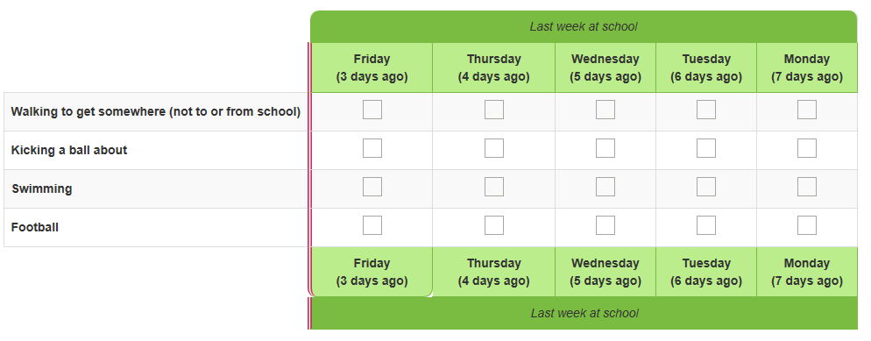
If pupils select a large number of activities, they may see separate grids showing groups of activities.

Please tell us on which days you did each of these activities while you were at school, during normal school hours.
ü Include activities in PE lessons and breaktimes
X Do not include activities at before and after school clubs, even if these took place at school
If you did not do one of the activities at school, during normal school hours, in the last seven days, just leave the row blank.
We will ask you about what you did outside usual school hours in the next question.
If you are completing this on a mobile or tablet, please scroll across to see all weekdays and enter your answers.

Question 8
Pupils who selected at least one activity at Question 5 are now shown a second grid with the activities they selected on the left-hand side and all seven days of the week across the top. For example:
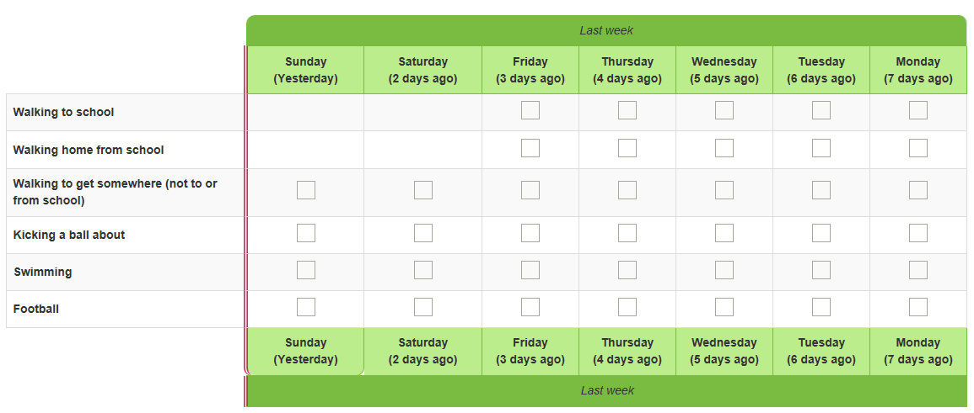

Now please tell us on which days you did these activities outside school hours.
If responded ‘Yes – every weekday’ to Question 1
ü Include activities you did:
- Before you got to school and after you left school
- At the weekend
- On holiday days
- At before and after school clubs, even if these took place at school
If you did not do one of the activities outside school hours in the last seven days, just leave the row blank.
If you are completing this on a mobile or tablet, please scroll across to see all weekdays and enter your answers.

Question 9
Pupils who say that they did any activities outside school hours, will be asked the following questions once for each activity.

You told us that on [day of the week], [X days ago], you [activity] outside normal school hours.

How long did you [activity] for?
As an example, if a pupil fills in the grid to show they played rugby on Friday, seven days ago, this question will ask “You told us that on Friday, 7 days ago, you played rugby outside normal school hours. How long did you play rugby for?”
- Less than 10 minutes
- About 15 minutes
- About 30 minutes
- About 45 minutes
- One hour
- More than an hour
- Cannot give an estimate

And did you [activity] indoors, or outdoors?
- Indoors
- Outdoors
The indoors/ outdoors question will not be asked in relation to:
- Walking to get to school or other places
- Going on a walk
- Riding a scooter
- Cycling to get to school or other places
- Climbing or swinging in the playground, garden or park
- Cycling for fun
- Sports day
- Field athletics
- Rounders
- Dancing
- Kicking a ball about
- Swimming
- Football
- Hockey
- Rugby
- Running/jogging
- Gym or fitness
- Horse riding
- Martial arts
- Boxing

Question 10
Pupils who said that they walked to or from school on any day will be asked this question.

How long does it usually take you to walk to / from school?
- Less than 10 minutes
- About 15 minutes
- About 30 minutes
- About 45 minutes
- One hour
- More than an hour
- Cannot give estimate

Question 11
Pupils who said that they cycled to or from school on any day will be asked this question.

How long does it usually take you to cycle to / from school?
- Less than 10 minutes
- About 15 minutes
- About 30 minutes
- About 45 minutes
- One hour
- More than an hour
- Cannot give estimate

Questions 12 & 13
Pupils who selected at least one activity at Question 5 will be asked the following questions for each activity they selected. Both questions appear on the same screen.

When you [activity], did it make you breathe faster than sitting down reading?
- Yes
- No

When you [activity], did it make you hot or tired?
- Yes
- No

Questions 14 to 17
These questions are asked to all pupils and appear on the same screen. Pupils should be encouraged to think about all types of physical activity rather than a specific sport or type of exercise when answering these questions.

We would now like you to think about all types of exercise and sport.

How much do you agree or disagree with the following statements?

I enjoy taking part in exercise and sports.
- Strongly agree
- Agree
- Disagree
- Strongly disagree
- Can’t say

I feel confident when I exercise and play sports.
- Strongly agree
- Agree
- Disagree
- Strongly disagree
- Can’t say

I find exercise and sports easy.
- Strongly agree
- Agree
- Disagree
- Strongly disagree
- Can’t say

I understand why exercise and sports are good for me.
- Strongly agree
- Agree
- Disagree
- Strongly disagree
- Can’t say

Questions 18 to 20
These questions are asked to all pupils and appear on the same screen.

How much do you agree or disagree with the following statements:

I feel that I have the opportunity to exercise and play sports
- Strongly agree
- Agree
- Disagree
- Strongly disagree
- Can’t say

I exercise and play sports to stay fit and healthy
- Strongly agree
- Agree
- Disagree
- Strongly disagree
- Can’t say

I exercise and play sports to help me relax and worry less about things
- Strongly agree
- Agree
- Disagree
- Strongly disagree
- Can’t say

Questions 21 to 23
These questions are asked to all pupils and appear on the same screen.

I work well with other children when doing exercise and sports
- Strongly agree
- Agree
- Disagree
- Strongly disagree
- Can’t say

Taking part in exercise and sports matters to me
- Strongly agree
- Agree
- Disagree
- Strongly disagree
- Can’t say

Exercising and doing sports makes me feel better about myself
- Strongly agree
- Agree
- Disagree
- Strongly disagree
- Can’t say

Questions 22 to 25
These questions are asked to all pupils and appear on the same screen.

I am good at exercise and sports
- Strongly agree
- Agree
- Disagree
- Strongly disagree
- Can’t say

I am kind when playing and being active with other children when doing exercise and sports
- Strongly agree
- Agree
- Disagree
- Strongly disagree
- Can’t say

I know where and how to get involved in exercise and sports
- Strongly agree
- Agree
- Disagree
- Strongly disagree
- Can’t say

I keep taking part in exercise and sports when it is challenging
- Strongly agree
- Agree
- Disagree
- Strongly disagree
- Can’t say

Question 26

I feel my opinions are valued by the adults who organise my exercise and sport activities
- Strongly agree
- Agree
- Disagree
- Strongly disagree
- Can’t say

Questions 27 to 28
These questions are asked to all pupils and appear on the same screen.

Outside of school there are places I can exercise that are inclusive and welcoming
- Strongly agree
- Agree
- Disagree
- Strongly disagree
- Can’t say

I see people who are similar to me if I exercise outside of school
- Strongly agree
- Agree
- Disagree
- Strongly disagree
- Can’t say

Question 29

Can you swim?
- Yes
- No

Question 30
Asked if pupil answered ‘Yes’ to Question 29.

Can you swim a length of a swimming pool (25 metres) without stopping?
- Yes
- No

Question 31

Can you stay in one place in the pool and keep your head above the water without holding onto the side or a float, and without touching the bottom of the pool? This is sometimes called treading water.
- Yes
- No

Question 32

Imagine that tomorrow you fall into a large lake. The lake is deep and you can’t touch the bottom. You have all your clothes on, and you are about five metres away from the land (this is the length of a large car). Could you get back to the land without someone helping you?
- Yes
- No

Question 33

Which of these outdoor places can you go to exercise or play?
Select all that apply
- A balcony
- A garden or backyard
- A park or field
- Outdoor sports places such as pitches or tennis courts
- A wood or countryside
- Beach or seaside
- In a lake, river, canal
- A road or pavement where you can safely go for a run or walk or ride your bike or scooter
- Other place outside your house or flat (e.g. cycle way, path along river)
- None of these

Question 34

Since [current month] last year, have you volunteered, or given your time to do any of the following activities?
Select all that apply
- Raised money for a sports club, organisation or event (only include fundraising for sport, not fundraising by taking part in a sports event or activity)
- Been a ‘sports leader’ or ‘sports ambassador’
- Coached or instructed an individual or team(s) in a sport, dance or fitness activity (other than solely for family members)
- Refereed or umpired at a sports match, competition or event
- Acted as a steward or marshal at a sports or dance activity or event
- Provided any other help for a sport, dance or fitness activity (e.g. helping with refreshments; setting up sports kit or equipment, scoring matches, first aid). Please tell us what you did:
________________
- No, have not done any of these activities since [current month] last year

Question 35

Overall, how happy did you feel yesterday?
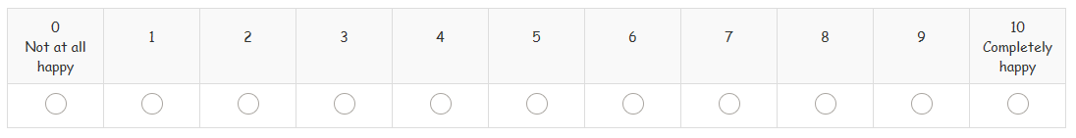

Question 36

Overall, how satisfied are you with your life nowadays?
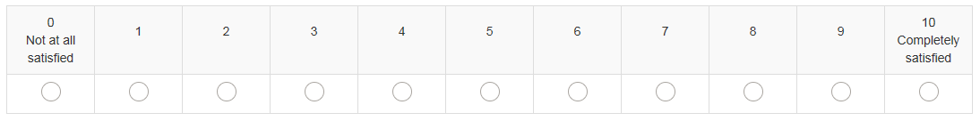

Question 37

Overall, to what extent do you feel that the things you do in your life are worthwhile?
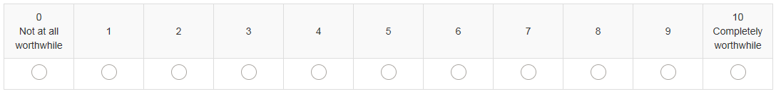

Question 38
For this question pupils should be encouraged to think about all activities, not just sport and physical activity. Icons are shown to help illustrate this.

Thinking about all the things you do at school and at home, how much do you agree or disagree with the following statement:

If I find something difficult, I keep trying until I can do it.
- Strongly agree
- Agree
- Disagree
- Strongly disagree
- Can’t say

Question 39

How much do you feel you can trust people who are a similar age to you?
- I can trust them a lot
- I can trust them a bit
- I can’t trust them very much
- I can’t trust them at all
- Can’t say

Question 40

How often do you feel lonely?
- Often/always
- Some of the time
- Occasionally
- Hardly ever
- Never
- Prefer not to say

Question 41
How often do you feel you belong at school? Belong means feeling that you fit in at school
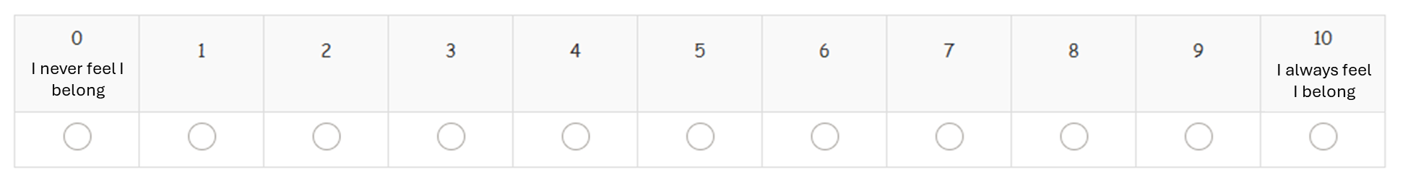
Question 42

Since [current month] last year, which of these clubs, groups or activities have you done, including school clubs?
Please select all that apply
- A sports club or fitness class (e.g. football, netball, running club, dance or swimming lesson)
- Art, music or drama class or club
- A group like Scouts, Girl Guides, Sea Cadets, Boys Brigade etc
- A youth club, (e.g. in a local hall or youth centre)
- Volunteering (e.g. at a charity, community centre or care home)
- Outdoor/adventure activities (e.g. orienteering, hiking, rock-climbing).
- Any other group or club (e.g. debating, chess, board games, computing club, etc)
- None of these
- Can’t remember
- Don’t know

Question 43
Since [current month] last year, have you gone on a trip for a whole day or overnight as part of any clubs, groups or activities or with your school?
- Yes
- No
- Can’t remember
- Don’t know

We now have some final questions about you.

Question 44

Year 7-8

Are you a…
- Girl
- Boy
- Prefer not to say

Year 9-11

What is your sex?

When you are considering how to answer, use the sex recorded when you were born.
- Female
- Male
- Prefer not to say

Question 45
Year 9-11

Which of these best describes your gender?
- Girl
- Boy
- Prefer to type in
- Prefer not to say

Asked if pupil answered “Prefer to type in”

How would you prefer to describe yourself?
- ________________
- Prefer not to say

Question 46

How old are you?
- 11
- 12
- 13
- 14
- 15
- 16

Question 47

Which one of these best describes your background or race?
- White (British or English)
- White (not British or English)
- Mixed e.g. White and Black , White and Asian
- Asian or British Asian
- Black or Black British
- Another group (please type in)
- Prefer not to say

Question 48

Do you have a disability, special need or medical need (e.g. autism, dyslexia, or asthma), which makes it difficult for you to do any of these things?
- Yes
- No
- Don’t know
- Prefer not to say

- Concentrating and paying attention (includes ADHD)
- How you behave in a way which makes life difficult (includes anger problems)
- Reading or writing (includes dyslexia)
- Using numbers (e.g. putting numbers the wrong way around)
- Difficulty learning or understanding new things (includes finding it hard to remember things)
- How you feel [and your mental health] (including feeling anxious or depressed)
- Co-ordination (includes balance problems
- Moving around including walking and running
- Using your hands for writing or to pick things up (includes difficulty holding a pen)
- Seeing and using your eyes (includes colour blindness)
- Hearing and using your ears
- Speaking and communicating
- Breathing (includes asthma)
- Gives you pain (e.g. hypermobility)
- Affects your health for a long time (includes conditions such as diabetes)
- Something else you have difficulty with because of your disability, special need or illness

Question 49
Asked if answered ‘Yes’ to Question 48.

Which of these do you have difficulty with because of your disability, special need or medical need?
Select all that apply
- Concentrating and paying attention (includes ADHD)
- How you behave in a way which makes life difficult (includes anger problems)
- Reading or writing (includes dyslexia)
- Using numbers (e.g. putting numbers the wrong way around)
- Difficulty learning or understanding new things (includes finding it hard to remember things)
- How you feel [and your mental health] (including feeling anxious or depressed)
- Co-ordination (includes balance problems
- Moving around including walking and running
- Using your hands for writing or to pick things up (includes difficulty holding a pen)
- Seeing and using your eyes (includes colour blindness)
- Hearing and using your ears
- Speaking and communicating
- Breathing (includes asthma)
- Gives you pain (e.g. hypermobility)
- Affects your health for a long time (includes conditions such as diabetes)
- Something else you have difficulty with because of your disability, special need or illness
- None of these
- Don’t know
- Prefer not to say

Question50
Asked if answered any response bar ‘None of these, ‘Don’t know’ or ‘Prefer not to say’ to Question 49.

Does this disability, special need or medical need have a big effect on your life?
- Yes
- No
- Don’t know
- Prefer not to say

Question 51
Asked if answered any response bar ‘None of these, ‘Don’t know’ or ‘Prefer not to say’ to Question 49.

Do you think this disability, special need or illness will last for a year or more?
- Yes
- No
- Don’t know
- Prefer not to say

Question 52

Thinking about school meals (food served by the school). Do your parents have to pay if you have school meals?

If you don’t normally have school meals please tell us whether you think your parents would have to pay if you had a school meal.
- Yes
- No
- Don’t know
- Prefer not to say

Question 53
If a pupil spends their time living in different homes with different parents or carers, they should answer these questions thinking about the home they will stay at tonight.
We would now like to ask you some questions to understand more about your home and your family.
These questions will help us find out more about what affects how much sport and exercise children and young people do.

Does your family own a car, van or truck?
- No
- Yes, one
- Yes, two or more
- Prefer not to say

Question 54

Do you have your own bedroom for yourself?
- Yes
- No
- Prefer not to say

Question 55

How many computers does your family own (including laptops and tablets/iPads, but NOT including game consoles and smartphones)?
- None
- One
- Two
- More than two
- Prefer not to say

Question 56

How many times did you and your family travel out of England for a holiday last year?
- None
- Once
- Twice
- More than twice
- Prefer not to say

Question 57

How many bathrooms (room with a shower/bath or both) are in your home?
- None
- One
- Two
- More than two
- Prefer not to say

Question 58

Does your family have a dishwasher at home?
- Yes
- No
- Prefer not to say

Final screen
Pupils’ answers are automatically submitted. Once they reach this screen they can close the browser.

Thank you! That is the end of the survey.
If you have questions or are worried about anything in the survey, or anything else in your life the first person to talk to is a parent, other family member or someone else you trust, if you feel able to.
If you want more information or someone else to talk to there are some ideas below.
It is absolutely fine if you don’t need or want to talk to someone – we are providing this to everyone who takes part. None of the organisations listed will know that you took part in the survey, nor will they get in touch with you.
NHS: www.nhs.uk
This site helps you make choices about your health, exercise and healthy eating and has information on finding and using NHS services. For advice and information on being physically active please visit: https://www.nhs.uk/live-well/exercise/physical-activity-guidelines-children-and-young-people/
CHILDLINE: 0800 11 11
A confidential and free helpline which will not appear on a phone bill. You can also go online for a 1-2-1 instant messenger chat with someone who is there to listen and support you at www.childline.org.uk
Kooth: https://explore.kooth.com/
Kooth is an online platform to help young people with their mental health and wellbeing. It’s a welcoming space to safely explore your feelings. You can confidentially talk to other people your own age on moderated discussion forums, and chat to mental health professionals via messaging. Kooth is not available in some areas but their website has helpful information you can access wherever you live

