Active Lives Children and Young People Survey

Invitation leaflet for schools


What is the Active Lives Survey?
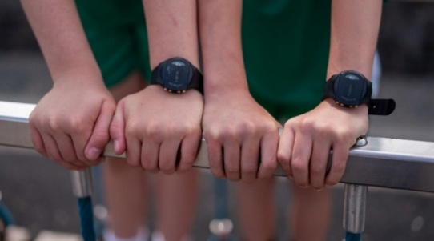
Sport England and Ipsos run the Active Lives Survey, which asks children and young people what sport and physical activities they take part in, both in and out of school. Your school has been selected to take part in the online survey. We would also like some of your pupils to wear a movement monitor on their wrist to measure how much movement and rest they do across a week. The movement monitor is a GENEActiv device from ActivInsights. For short we call it ‘Genie’.

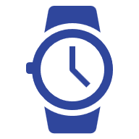
What is a Genie?
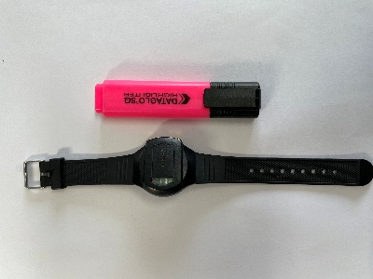
We are asking children and young people to wear a wrist-worn movement monitor that looks like a black faceless watch. Genies do not have a screen, or a camera, or internet or Bluetooth connection. Genies sense movement and do not measure location or send any live data whilst pupils are wearing them.


What is device-based measurement?
Genies continually measure movement and periods of rest, so we can see how much movement children and young people do across a week. We would like pupils to wear a Genie 24 hours a day, for 7 consecutive days. All movement data is stored on the watch. This is not an activity competition for pupils or schools. Further information about the Genie is provided in the school guide. You will receive this once you have agreed to participate.

What would we like your school to do?
Three classes per school are invited to complete the online survey and two of these selected classes are invited to also wear Genies. Your Active Partnership will inform you which year groups these will be in and how to select one class per year if needed. Please invite all the pupils in the classes to take part. We will provide you with pupil and parent invitation letters as well as consent forms which you will need to distribute and collect using your usual online permission system. You will be sent the Genies, and you will need to give these out at school. The Genies will be provided fully charged, you and your pupils will not need to charge them.
If there are high consent rates at your school, not every pupil will receive a Genie. We will let you know if we cannot provide Genies to all pupils who have consented and will randomly select those who will receive a Genie from among those consenting.
If more than one school in your area agrees to take part in the Genie study, it may not be possible for your school to invite your pupils receive Genies but we would still like you to do the survey with your pupils.


What happens when pupils have worn it for 7 days?
After the 7 days, you will need to collect the Genies from your pupils. You will need to package these in the same box they were delivered in for the courier to collect. It is very important that pupils complete the online Active Lives survey during the week when they are wearing the Genie. This involves answering some questions about their activities and what they think about them. They will need to input their Genie number into the online survey, so please help them to have this information ready.

What happens if pupils are required to take it off?
We understand that your pupils may need to take off the Genie during certain sports or lessons at school. Please make sure there is a safe place for pupils to store their Genie, where it cannot be mixed up with other Genies. Please ensure pupils are putting their Genie straight back on afterwards.

What happens if pupils lose or damage the Genie?
If a Genie gets damaged or lost, please let your Active Partnership know as soon as possible. The school and pupil are not responsible for the devices and will not be charged or have to pay any money to fix or replace the Genie. It is not possible to provide schools with another Genie, but pupils can still complete the online survey.


How do I take part?
If you would like to take part please inform your Active Partnership.

Why should we take part?

For completing the online survey, your school will receive a personalised school report (at least 25 responses completed), 10 credits (worth £100) to spend on equipment and a healthy schools rating certificate to display. If you take part in device-based measurement (and receive the necessary teacher survey responses), your school will receive additional credits (~£75) for each class that takes part, a report on device-based measurement and a certificate confirming your participation in the study.


What is the aim of Active Lives?
The Active Lives Survey gathers data on how children engage with sport and physical activity. This is to understand whether children and young people are meeting the Chief Medical Officer’s guidelines for children’s physical activity of 60 minutes a day. This will provide you with key data to help understand children’s attitudes and behaviours around sport and activity. It helps Sport England, the government and other partners to shape future policy and investment decisions. We are trialling device-based measurement to obtain a more comprehensive understanding of children and young people’s physical activity and inequalities in participation.

How can I find out more?
If you have any questions or you would like to know more about the Genie or the survey, you can speak to your Active Partnership. You can also read the Privacy Notice (www.sportengland.org/ALCYPprivacypolicy) which contains more information.

