Dear Parent / Guardian,

Study about sport and physical activity for children and young people
Our school and Sport England would like to find out about the sports and physical activities our pupils take part in, both in and out of school. Your child’s [Year 1 or 2] class has been selected to take part in the study. This involves completing a short online survey at school about what they think about sport and exercise.
In addition to completing the online survey, we would like your child to wear a movement monitor on their wrist to measure how much movement and rest they do across a week. Your child’s whole class is invited to take part in wearing movement monitors.
The movement monitor is a GENEActiv device from ActivInsights. For short we call it ‘Genie’.
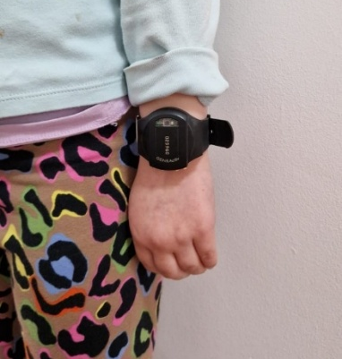
- The GENEActiv monitor looks like a black faceless watch and measures your child’s movement during the day and when they are resting.
- We would like them to wear a Genie 24 hours a day, for 7 consecutive days.
- Genies cannot be used to locate your child and do not send any live data whilst they are wearing it.
- All the movement data is stored on the Genie.
You will also have received an additional letter about the online survey for parents. Whether or not your child wears a Genie it is really important that you also complete the short online survey about their activities.
The information collected will be used to:
- Provide a report to our school to help us understand how many pupils agreed to take part and then wore a Genie. The report will also include findings from the survey to help us understand what our pupils are doing and what we can do to support them
- Help Sport England invest in opportunities for children and young people
Consent process:
If you agree for your child to wear a Genie on their wrist and take part in this survey, please sign the consent form we have provided. You need to fill this in with your child who will also need to consent. If your child does not want to wear a Genie or you don’t want your child to, you do not need to do anything.
If you do not want your child to take part in the survey, please let [contact teacher] or your child’s class teacher or tutor know.
The surveys are hosted by Ipsos, a research organisation. The University of Exeter will supply the Genies and download and analyse the data. Ipsos and the University of Exeter will store all information securely and keep it confidential.
Further information can be found on the next page or contact [contact teacher] if you have any questions.
Many thanks,
[INSERT NAME OF TEACHER/SCHOOL]
Helen Price
Principal Analyst Quantitative Research
Sport England

What is the Active Lives Survey?
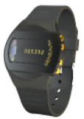
Sport England and Ipsos run the Active Lives Survey, which asks young people what sport and physical activities they take part in, both in and out of school. In addition to completing the online survey, we would like your child to wear a movement monitor on their wrist to measure how movement and rest they do across as week. This is not an activity competition for pupils or schools. The results help Sport England, the government and other partners to shape policy and future investment decisions.

What is a Genie?

The movement monitor is a GENEActiv device from ActivInsights. For short we call it ‘Genie’. It looks like a black faceless watch and is worn on the wrist.

What do Genies do?
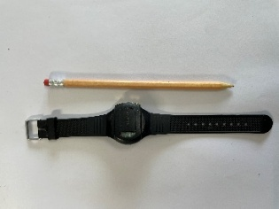
Genies continually measure movement and periods of rest, so that we can see how much movement and rest children and young people do across a week.
What is not measured?
Genies do not measure heart rate, pulse or the type of activity your child is doing. Genies do not have a screen, or a camera, or internet or Bluetooth connection. It cannot be used to locate your child and does not send any live data whilst they are wearing it. All the movement data is stored on the Genie and it is not possible to see what it is measuring. Genies do not vibrate or make a noise.

Do I have to charge the Genie?

A Genie will be given to your child fully charged and it will not need charging. The charge will last for the whole 7 days as there is no screen or GPS so the battery life is longer than a typical smart watch.

What will my child have to do?
Your child will be asked to wear a Genie for 24 hours a day, for 7 consecutive days, including when they are asleep. Genies are waterproof and can be worn at all times, including whilst bathing or showering and during swimming. There may be some sports that your child could be asked to remove the device for, such as invasion games or during playground activities at school. However, we will provide your child with a note to show to sports coaches to explain why they are wearing the device. The children can also wear a sweat band (provided) over the top of the monitor during sports if required.
Your child’s name is not linked to the data collected by the Genie.
We will also ask your child to take part in an online survey during the week when they are wearing a Genie. The school will tell them how. Their teacher will also ask you to help your child complete a paper feedback form on their experience of wearing the Genie. Please help them to complete this at home and return it to school at the end of the week of wearing the Genie.

What happens if the Genie is lost or damaged?
If the Genie gets lost or damaged, please let the teacher and school know as soon as possible. You will not be charged or have to pay to fix or replace the Genie. It is not possible to provide your child with another Genie, but they are still able to take part in the online survey!

What do I need to do?
If you and your child are happy to take part and for your child to wear a Genie for 7 days as part of the Active Lives Survey, please sign the consent form. You can find the form in your email inbox/ online on school platform/website. Please explain what this will involve to your child first, before asking if they would like to take part. They have received their own invitation leaflet. You will also need to complete the parent short online survey about the activities your child does. It is very important that you take part in the survey so we can make the best use of their Genie data. Please make a note of the six digit number on the front of your child’s Genie so that you can enter it into your survey.

Why were we chosen for the survey?
Everyone in your child’s class has been asked to do the survey and asked for consent to wear a Genie. It does not matter how much sport or exercise your child does. If there are high consent rates in your child’s class, not all the children will be given a Genie. If there are not enough Genies for all the children who consent, children who are given a Genie to wear will be selected randomly. Even if your child does not wear the Genie we would still like you and your child to complete an online survey.

How will the information my child provides be used?
Your child’s answers and movement data will be combined with other pupils’ answers and only anonymous data will be reported. The results will be presented in a statistical report, and no individual child or school will be identified in the published report or statistics. The summary report will not include information on sleep patterns even at a class or school level. No individual reports about your child’s movement and rest across the last 7 days will be produced.

Is confidentiality guaranteed?
Yes. Data will be used for research purposes only and in accordance with Market Research Society Code of Conduct and the General Data Protection Regulation (GDPR).
If you or your child has any concerns about data privacy, please refer to the accompanying Privacy Notices:
- Parents: www.sportengland.org/ALCYPprivacypolicy
These detail who Ipsos are, the personal data collected, how it is used, who it is shared with, and what your legal rights are in relation to this survey. The Privacy Notice has also been shared with teachers. Sport England and Active Partnerships (the organisations which recruit schools to take part) will know which schools and year groups have taken part but not the individual children or parents. The teacher organising this at your school will know which children are wearing a Genie but will not see the data being collected from it.
The University of Exeter processes personal data for the purposes of carrying out research in the public interest. The University will endeavour to be transparent about its processing of your personal data and this information sheet should provide a clear explanation of this. If you do have any queries about the University’s processing of your personal data that cannot be resolved by the research team, further information may be obtained from the University’s Data Protection Officer by emailing informationgovernance@exeter.ac.uk. or at http://www.exeter.ac.uk/ig/

What if I have more questions?
If you have further questions, please contact your class teacher or head to our FAQ page for more information regarding the Genies and the Active Lives Survey. [link to FAQ doc]

