Active Lives Children and Young People survey

Invitation leaflet for Year 3-6 pupils

What is Active Lives?

- Active Lives is the name of a survey
- It asks children some questions about exercise and sport
- A survey asks lots of people questions about what they think or do
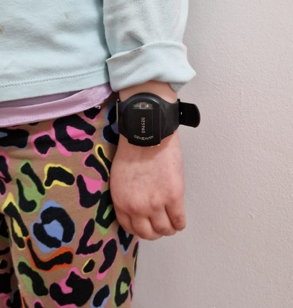
  - We are also asking children to wear a movement monitor on their wrist to measure how much play and sport they do
  - We call this movement monitor a ‘Genie’
  - Its full name is GENEActiv made by ActivInsights

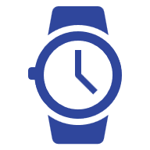
What would we like you to do?
- If you would like to take part, you would wear a Genie on your wrist
- It looks like a black watch
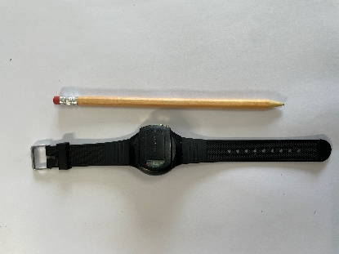
- We would like you to wear a Genie for 7 days, all day and all night, even when you are asleep!
- Your teachers at school will give you a Genie


What do Genies do?
- Genies count how much play and movement you do
- It also counts when you are not moving
- Genies are waterproof
- They can be worn in the shower/bath and when you are swimming!
- Genies are fully charged and will not need charging
- You won’t be able to make a big difference in how much movement the Genie counts by waving your arm around!
- All the movement data is stored on the Genie


What do Genies not measure?
- Genies do not have a screen or camera
- It does not have internet or Bluetooth
- It cannot be used to see where you are
- This is not a competition with your classmates


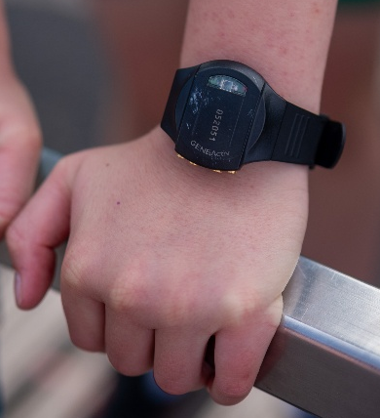
What happens next?
- If you want to wear a Genie tell your parents. If they are happy with you taking part ask them to fill in the consent form
- If you choose to take part and your parent/carer also agrees, you will be given a Genie during school by [insert teacher name]
- If lots of people consent it may not be possible for everyone to have a Genie
- If you are given a Genie we would like you to wear it all day and night, for 7 days in a row
- Your teachers will help you put it on your non-writing wrist
- If you wear a Genie we would also like you to answer some questions in a survey

What happens if I have to take it off?
- You may be asked to take off the Genie when you play some sports or during some lessons at school
- Your teacher will help you to put it somewhere safe
- Please put it straight back on afterwards
- If you cannot find it please tell your teacher


What happens when I have worn it for 7 days?
- You will be asked to do the online Active Lives survey while you are wearing the Genie
- It will ask you some questions about your sport and activities and what you think about them
- After the 7 days, your teacher will collect the Genies and ask for some feedback about what it was like to wear it

What happens if I lose or damage the Genie?
- If the Genie gets broken or lost, please tell a teacher as soon as possible
- We understand accidents happen
- We will not be able to give you another Genie, but you can still answer the online survey

What will happen to the information on the Genie?

Only your school will know your name and who you are so they can give you a Genie

We will just have information about how much you move and when and your answers to the questions in the survey

We will look after your information carefully

What happens if I don’t wear a Genie?
- Even if you don’t want to wear a Genie you can still do the survey.
- Tell your teacher if you do not want to do the survey

Do I have to answer all the questions in the survey?
- No, you don’t have to if you don’t want to

Will you tell anyone what I say in the survey?
- No. No one else will know what you have said
- You don’t have to tell anyone else what you have said

What if I have questions?
- If you have any questions or you would like to know more about wearing a Genie or the survey, you can speak to your teacher or your parent

