Active Lives Children and Young People survey

Invitation leaflet for Year 7-11 pupils


What is Active Lives?
Sport England and Ipsos run the Active Lives Survey, which asks young people what sport and exercise they take part in. As well as the survey, we would like you to wear a movement monitor on your wrist to measure how much you move during the day and while you are resting. The movement monitor is a GENEActiv device from ActivInsights. For short we call it ‘Genie’.

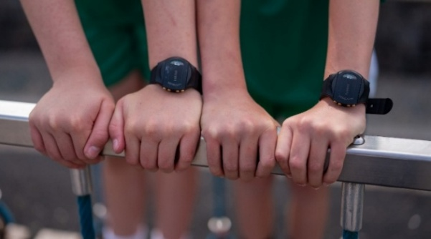
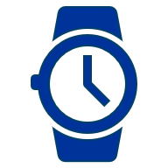
What would we like you to do?
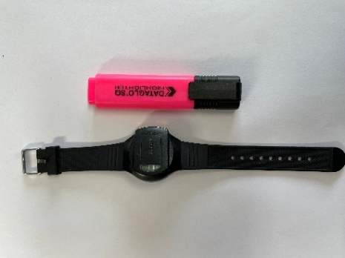
If you choose to take part, you would wear a Genie on your wrist that looks like a black faceless watch. We want to see how much movement and rest children and young people do across a week. The Genie will be given to you at school and we would like you to wear it for 24 hours for 7 days in a row.


What do Genies do?
Genies continually measure all your movement during the day and when you are resting. Genies are waterproof and can be worn at all times, including whilst washing and swimming. There may be some sports or lessons that you are you asked to take the Genie off for, such as contact sports. But we will give you a letter for your coaches so they know why you are wearing it. A Genie will be given to you fully charged and it will not need charging.


What do Genies not measure?
Genies do not measure heart rate, pulse or the type of activity you are doing. Genies do not have a screen, or a camera, or internet, or Bluetooth connection. It cannot be used to locate you and does not send any live data whilst you are wearing it. All the movement data is stored on the Genie and it is not possible to see what it is measuring. You won’t be able to meaningfully change how much activity Genie records by waving your arm around.


How do I take part?
If you would like to wear a Genie and your parent/guardian is also happy with you wearing a Genie please fill out the consent form your teachers have provided and return this back to school. Even if you choose not to wear the Genie we would like you to take part in the survey. Tell your teacher if you don’t want to.


What happens next?
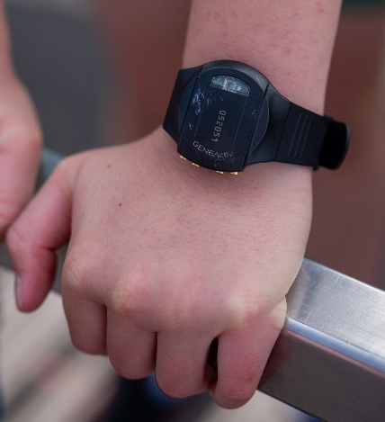
If you choose to wear a Genie, you will be given a Genie during school by [insert teacher name]. We would like you to wear it for 24 hours a day, for 7 full days in a row. A Genie is worn on your wrist and should be put on your non-writing wrist. Your teachers will help you to do this.
The monitor should be tight enough to the wrist so that it does not move around. You should have the gold buttons close to your hand if you wear it on your left wrist. If worn on your right wrist the buttons point to your elbow. You should be able to read the number on the front of the Genie. Genies will start automatically, you do not need to press anything. The buttons cannot be pressed - they are just there for the research team to connect the Genie for charging. If you wear a Genie we would also like you to answer some questions in a survey.

What happens if I have to take it off?
You may be asked to take off your Genie when you play certain sports or during certain lessons at school. Please make sure you put it somewhere safe where it cannot be mixed up with other Genies. Please put it straight back on afterwards.


What happens when I have worn it for 7 days?
Whilst you are wearing the Genie, during the 7 days, you will be asked to complete the online Active Lives survey which involves answering some questions about your activities and what you think about them. After the 7 days, your teacher will collect the Genies and ask for some feedback about what it was like to wear it.

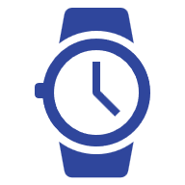
What happens if I lose or damage the Genie?
If the Genie gets damaged or lost, please let a teacher know as soon as possible. You will not be charged or have to pay any money to fix or replace the Genie. We understand that accidents happen. It is not possible to give you another Genie, but you can still complete the online survey.

Why are you asking me to wear a Genie?
Your Head Teacher agreed that your school would take part in the survey and your class or group was selected. Everyone in your class or group has been asked to do the survey and asked for consent to wear a Genie. Sport England want to understand the patterns of activity for all children and young people. If lots of people consent it may not be possible for everyone to have a Genie.

What will happen to the information I have given you?
Your data and survey responses will be held securely by the University of Exeter and Ipsos. It will be combined with information from pupils in other schools. The results will be presented as data (numbers) and no individual schools or pupils will be named in the findings published by Sport England. Sport England will know which schools took part and which year groups but will not know which individual pupils took part. The answers you have given on the online survey will not have your name on them, so no one else will know you said them. You do not have to tell your teachers, parents, or anyone else what you have said. No one will receive an individual report about your movement and rest across the 7 days. Your school will just receive an overall summary of information about everyone who took part at your school.
The research follows the rules in the Market Research Society Code of Conduct and Data Protection Act 2018.

How can I find out more?
If you have any questions or you would like to know more about wearing a Genie or the survey, you can speak to your teacher. You can read the Privacy Notice (www.sportengland.org/ALCYPprivacypolicyY7-11) which contains more information.
We also have a frequently asked question document which can be found here: LINK

