

Higher Education Sport Participation and Satisfaction Survey

National Report

2015/16

October 2016

Contents

1. Executive summary Error! Bookmark not defined.

2. Introduction 4

3. Who plays sport? 10

4. How do students engage in sport? 21

5. Volunteering 32

6. What do students value in sport? 35

7. Conclusions 43

Executive Summary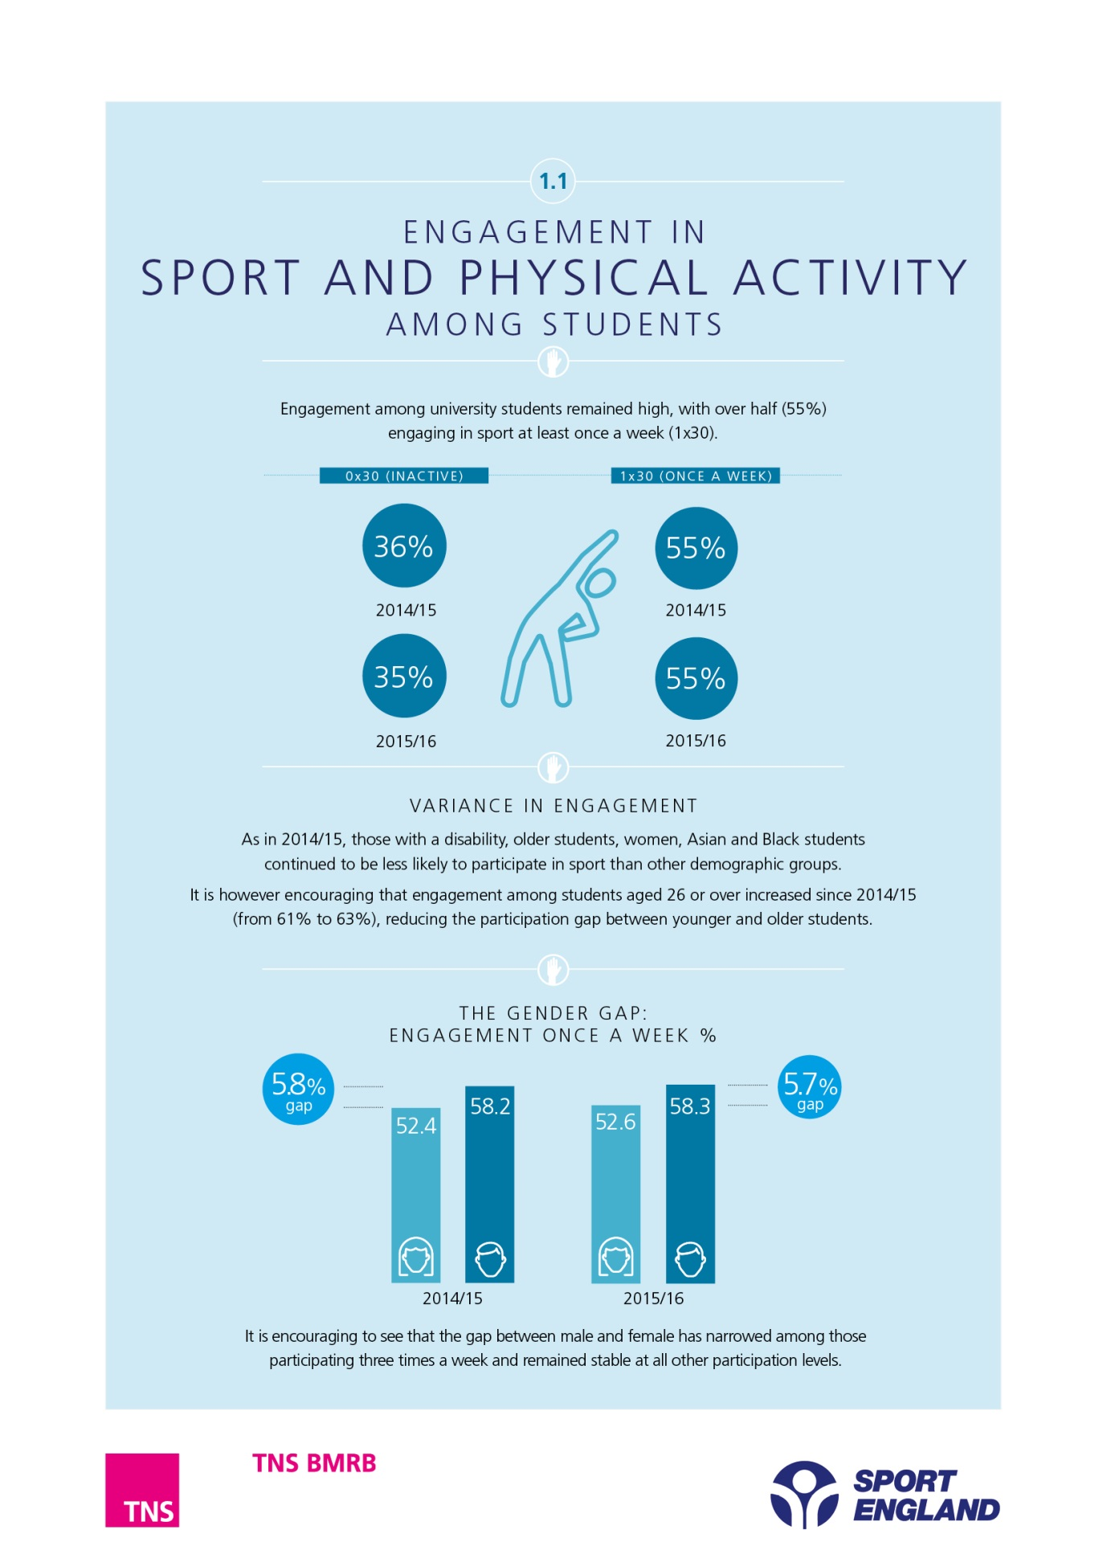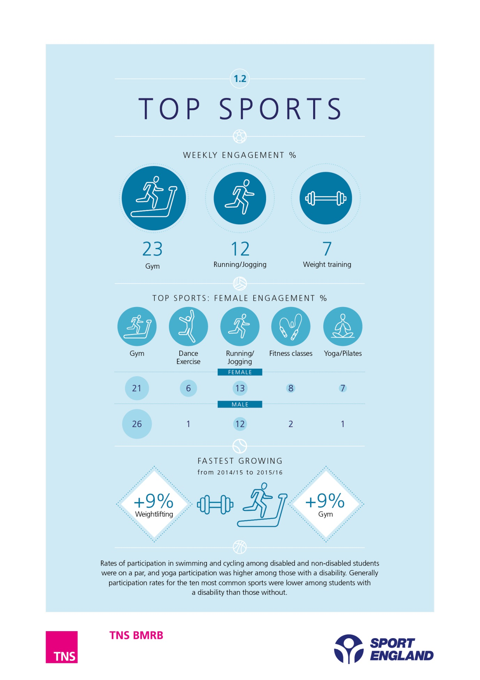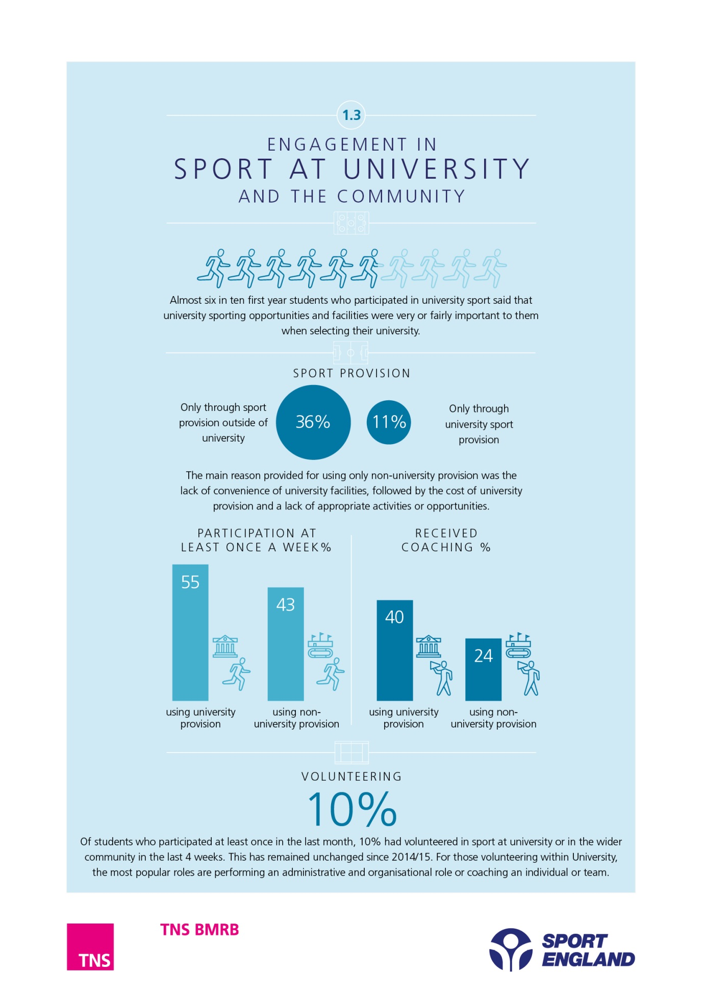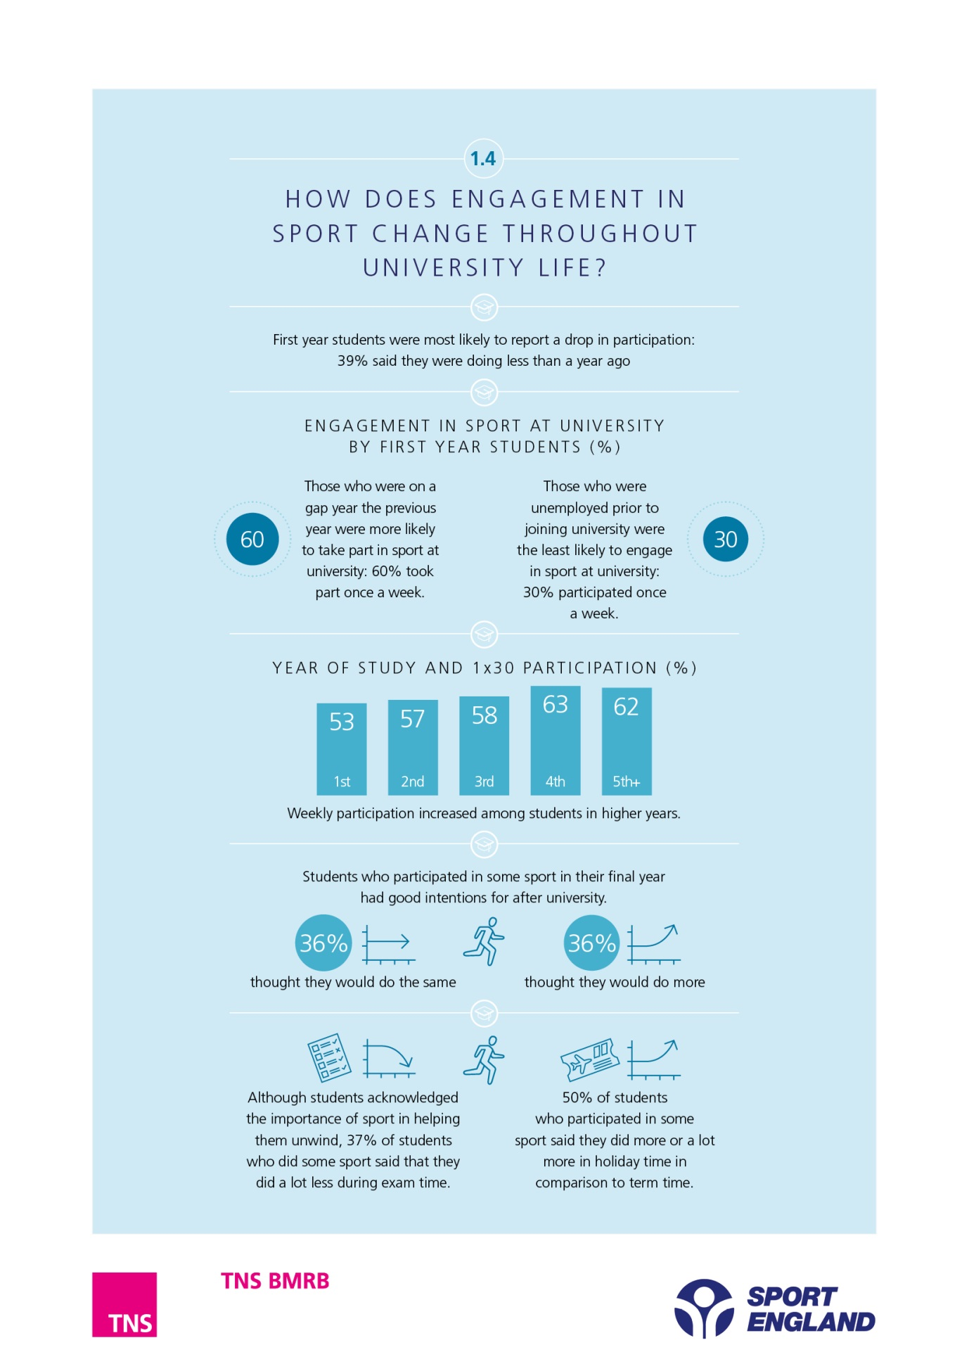 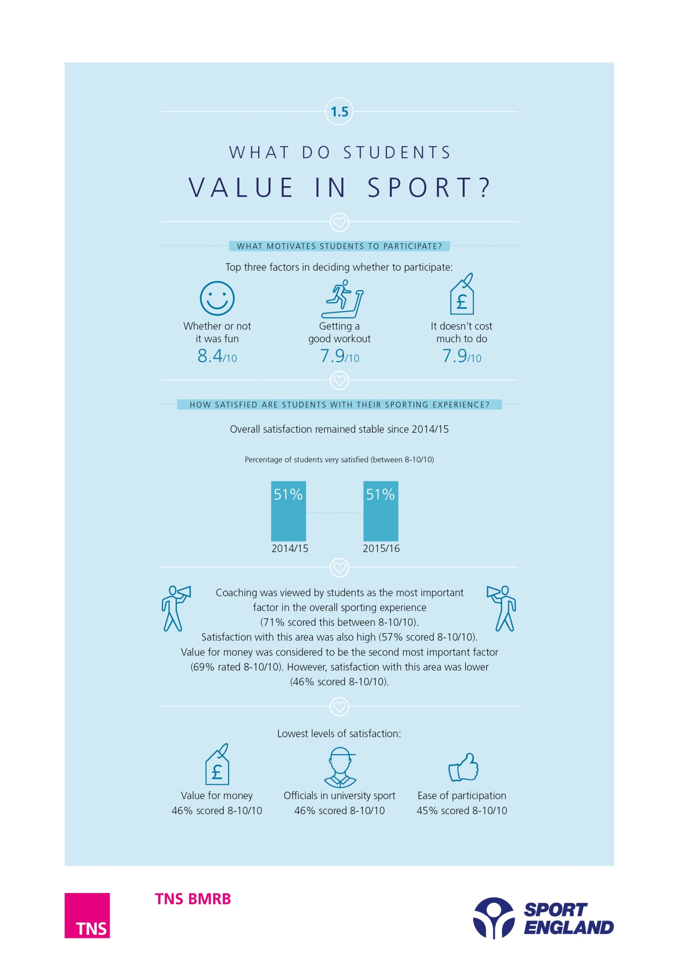

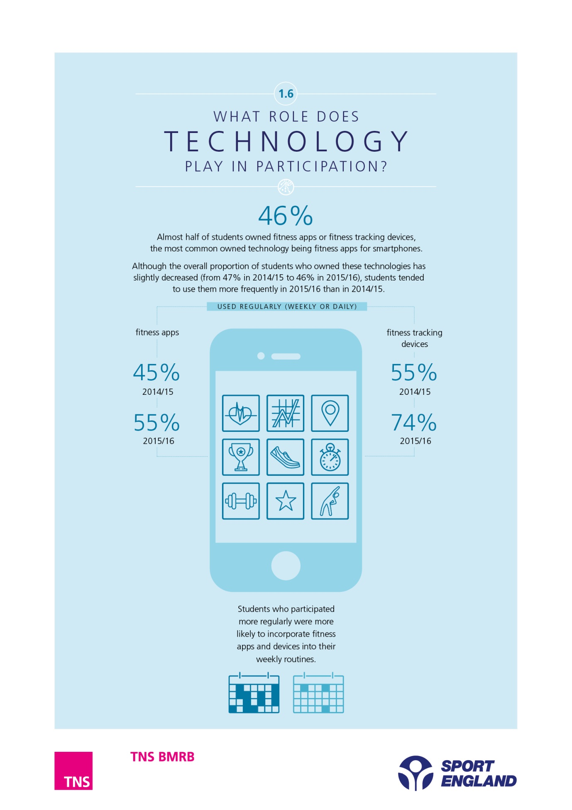

1. Introduction

The Higher Education Sport Participation and Satisfaction Survey measures higher education students’ sports participation and satisfaction with their sporting experience. The survey was originally developed as part of Sport England’s Active Universities themed funding round, to enable Sport England to manage and evaluate the impact of the programme.

In 2014 Sport England announced investment in universities through a new University Sport Activation Fund. This investment contributes to Sport England’s overall ambition of increasing the number of people in England taking part in sport and activity, regardless of age, background or ability, and decreasing the number of people who are physically inactive.

Sixty two universities are funded through this initiative, supporting projects with the aim of maintaining sports participation in universities, and increasing it by trialling new methods of getting students into sport and offering a wider variety of opportunities to keep them playing sport during their time at university.

Sport England will use the Higher Education Sport Participation and Satisfaction Survey to help to understand the impact of the new investment, and to performance manage projects. This will cover the academic years 2014/15, 2015/16 and 2016/17.

The study was also developed in order to test a sport participation tool for the Higher Education sector, to demonstrate how universities contribute towards increasing participation in community sport across England as well as to provide information to individual universities which may assist with influencing decisions made about sport provision. The Higher Education Sport Participation and Satisfaction survey provides data to each university to help understand how their students participate in sport and how satisfied they are with sport provision at the university.

The study, while remaining largely consistent with the previous study, has been expanded to cover some new areas including use of technology, motivations to participate and communications about sporting opportunities. Students were asked additional open-ended questions about their satisfaction with sporting provision, as well as their reasons for not participating in sport at all or through university provision. Student responses to these questions are cited within the report.

When the survey was relaunched in 2014/15, the number of HEIs involved increased to 70 HEIs (68 HEIs took part in 2015/16).

Data collected in the study were weighted within each HEI to ensure that the age and gender profile matched the HEI population. A further weighting factor was then applied to weight data according to the size of each HEI in order to report national findings. The targets used for the weighting were up to date population counts provided by HESA.

This report summarises the key national findings from the 2015/16 study, and makes comparisons with the 2014/15 study. Overall 47,041 students participated in 2014/15 and 45,022 in 2015/16.

In both years, the survey was conducted online, in November and May, with each wave lasting three weeks. The research was conducted in two waves to minimise seasonal impacts. The overall response rate was 7.9% for the Autumn wave and 6.4% for the Summer wave.

The fieldwork dates were as follows:

|  |  |
| --- | --- |
| **2014/15 Autumn wave** | 3 November – 1 December 2014 |
| **2014/15 Summer wave** | 5 – 26 May 2015 |
| **2015/16 Autumn wave** | 2 – 30 November 2015 |
| **2015/16 Summer wave** | 5 – 26 May 2016 |

All differences commented on in this report are statistically significant at the 95 per cent level.

1. Who plays sport?

The questionnaire captures details of participation (including number of days on which the respondent participated in the last 28 days, and average duration per session) in over 70 individual sports. This information was aggregated to create a measure of overall sports participation. The combined sports participation was grouped into six bands for analysis purposes:

* No participation (0x30) – not taken part in any sport for at least 30 minutes in the last 28 days.
* Less than once a week (>0x30<1x30) – participation in a session of at least 30 minutes of sport on between 1 and 3 of the last 28 days.
* Any participation (>0x30) – participation in a session of at least 30 minutes of sport on 1 or more of the last 28 days.
* Once a week (1x30) – participation in a session of at least 30 minutes of sport on at least 4 of the last 28 days.
* Twice a week (2x30) – participation in a session of at least 30 minutes of sport on at least 8 of the last 28 days.
* Three times a week (3x30) – participation in a session of at least 30 minutes of sport on at least 12 of the last 28 days.
  1. Trends in overall sport engagement

Sport engagement levels in 2015/16 were very similar to those from the 2014/15 survey. Two thirds (65%) of students in 2015/16 participated in some sport, with over half of these (33% of all students) engaging in high levels of sport activity (3x30 minutes per week).

The overall findings are summarised in Chart 3a and detailed results for each of the different frequencies are examined in turn in the sections that follow.

|  |
| --- |
| Chart 3a: Key participation measures |
| Base: All students, 2014/15 (47,041), 2015/16 (45,022) |

* 1. Inactive students (Non participation) (0x30)

Students are defined as non-participants if they have not taken part in any sport for at least 30 minutes during the past 28 days. In the latest study, just over a third (35%) of students were classified as non-participants. The level of non-participation was similar in 2014/15 (36%).

Respondents were asked to indicate, from a list of options, why they had not participated in any sport in the last 28 days. The main reasons given are shown in Chart 3b.

As in 2014/15, the most common reason given for not participating in sport was lack of time due to study or work commitments. The proportion of students who cited this as a reason increased from 68% of non-participants in 2014/15 to 70% in 2015/16.

I work full time and trying to study too does not leave much personal time.

Other key reasons given were a preference to spend time doing other activities (40%), the expense of sporting activities (27%) and family commitments (13%).

|  |
| --- |
| Chart 3b – Reasons for not participating in sport |
| Base: Students who do not participate in any sport 2014/15 (12,528), 2015/16 (11,960) |

Two in five students who had not engaged in any sport said this was because they preferred to do other activities.

Although the most common reasons were similar for both genders, women were more likely to cite the cost of participation (31% women compared to 20% men) and family commitments (15% women compared to 10% men) as reasons for not engaging in sports.

Disabled students were more likely than students without disability to cite their health problems participating barrier to participation but, as in the case of other demographic groups, the key barrier for students with disability was also lack of time due to work or study commitments.

The questionnaire collected details of whether students had done a range of other activities in their free time. Table 3a shows the proportion of students who took part in these other activities, comparing those who had not participated in any sport (0x30) with those who had taken part in sport at least once a week (1x30).

Table 3a: Comparison of other activities preferred by students who did no sport (0x30) and who participated once a week (1x30)

|  |  |  |
| --- | --- | --- |
|  | **Sport participation level (2015/16)** | |
| **0x30**  (Base: 15,853) | **1x30**  (Base: 24,791) |
| Spend time with friends/family | 87% | 92% |
| Read | 73% | 79% |
| Listen to music | 87% | 91% |
| Watch TV | 79% | 83% |
| Days out or visits to places | 68% | 77% |
| Eat out at restaurants | 82% | 89% |
| Go to pubs/bars/clubs | 66% | 80% |
| DIY | 25% | 32% |
| Gardening | 15% | 20% |
| Shopping | 81% | 85% |
| Arts and crafts | 28% | 30% |
| Play a musical instrument | 20% | 25% |
| Go to cinema | 71% | 79% |
| Visit museums/galleries | 45% | 52% |
| Theatre/music concerts | 42% | 53% |
| Play computer games | 49% | 50% |
| Internet/emailing | 85% | 89% |
| Visits to historic sites | 37% | 45% |
| Voluntary work | 24% | 33% |
|  |  |  |

As the table shows, non-participants did not appear to be more likely than regular participants to have taken part in these other activities. It is however important to note that the study did not capture the length of time that respondents spent doing each of these activities, so it is possible that those who did less sport spent longer on other pastimes.

* 1. Any participation (>0x30)

>0x30 is defined as participation in a session of at least 30 minutes of sport on 1 or more of the previous 28 days. 65% of students had done at least one session of 30 minutes of sport in the 28 days leading up to the survey.

As in 2014/15, women, those with a disability, older students, Asian and Black students were less likely to engage in sport than other groups. Unlike in 2014/15, postgraduate students were more likely to participate in sport than undergraduates in 2015/16 (66% of postgraduates compared to 65% of undergraduates). Postgraduate students, however, tended to engage in sport less frequently.

Table 3b: Participation in any sport (>0x30) by demographic group, 2015/16

|  |  |
| --- | --- |
|  | **Sport participation level** |
| **>0x30**  (Base: 29,169) |
| **Gender** |  |
| Male | 67% |
| Female | 63% |
| **Disability** |  |
| Has a disability | 56% |
| Does not have a disability | 67% |
| **Ethnicity** |  |
| White | 68% |
| Mixed/multiple ethnic groups | 66% |
| Asian/Asian British | 55% |
| Black/Black British | 55% |
| Other | 55% |
| **Age** |  |
| Up to 19 | 64% |
| 20-25 | 66% |
| 26-29 | 66% |
| 30-34 | 63% |
| 35-44 | 58% |
| 45-64 | 58% |
| 65+ | 42% |

Over a half (56%) of students with a disability took part in some sport in 2015/16, a similar percentage to 2014/15. Similarly, the proportion of female and male students who participated in any sport remained stable from 2014/15 to 2015/16, with 63% of women and 67% of men having participated in some sport in 2015/16. Participation levels of ethnic minorities also remained similar to those from 2014/15, with over 6 in 10 Mixed (66%), over a half of Asian (55%) and over a half of Black respondents (55%) having participated in some sport in 2015/16. The overall proportion of students aged 26 or over who participated in sports increased from 61% in 2014/15 to 63% in 2015/16. Therefore, the gap in participation between students aged 25 or younger and those over 25 narrowed from 5% in 2014/15 (66% of students aged 25 or younger compared to 61% of students aged 26 or over) to 3% in 2015/16 (65% of students aged 25 or under compared to 63% of those over 25).

* 1. Less than once a week (>0x30 & <1x30)

>0x30 and <1x30 is defined as participation in a session of 30 minutes of sport on between 1 and 3 of the previous 28 days. This is the equivalent of doing sport less than once per week. Similarly to 2014/15, one in ten students in 2015/16 (10%) engaged in sport at this level.

* 1. Once a week (1x30)

1x30 is defined as participation in a session of at least 30 minutes of sport on at least 4 of the previous 28 days. Participation levels remained high in 2015/16, with over half (55%) of students having participated 1x30 - the equivalent of at least once a week in the 4 weeks before the survey. Once a week participation has remained the same since 2014/15.

Students in their first year of university were more likely to participate once a week if they had previously been on a gap year. 60% of first years who had had a gap year prior to joining university engaged in sport at this level, in comparison to 55% who had been in a school sixth form, 53% who had been in employment and 51% who had attended a Sixth Form College.

Students who had been unemployed at the year preceding were the least likely to participate at this level (30%), followed by those who had been at Further Education College (45%).

Chart 3c shows the 10 sports that have the highest level of 1x30 participation across the whole student population. Around one in five students (23%) went to the gym at least once a week, followed by 12% who did running at least once a week. For other sports the 1x30 participation rate was less than 10%. The proportion of students exercising at gym and doing weightlifting had increased slightly since 2014/15, although the proportion of students taking part in fitness classes, running and jogging and football had decreased.

|  |
| --- |
| Chart 3c – Top 10 Sports at 1x30, 2015/16 |
| L:\8 Charting_2016\1 Clients\Sports England\260127195 HESPSS Updates\Originals\Chart 3c.png  Base: All students, 2015/16 (45,022) |

While female students continued to be less likely than male students to participate at 1x30 level in 2015/16, weekly sport engagement remained stable for students of both genders since 2014/15.

Sports participation was found to vary by gender and some of the top 10 sports were characterised by higher rates of participation among women than among men. Women were more likely to take part in fitness classes (8% of women compared to 2% of men), yoga (7% of women; 1% of men), do swimming, diving and water polo (5% of women; 3% of men), running and jogging (13% women; 12% men) and dance exercise (6% of women; 1% of men). Men were more likely to use a gym (26% of men compared to 21% of women), cycle (9% of men; 5% of women), do weight training (10% of men; 5% of women), play football (10% of men; 1% of women), or do weightlifting (7% of men; 2% of women). Chart 3d shows the 10 sports that had the highest level of 1x30 participation among men, and Chart 3e shows sports with the highest level of 1x30 participation among female students. The top three sports among male students were going to the gym, running and jogging, and playing football. The sports that had the highest participation levels among women were using the gym, running or jogging and attending fitness classes.

|  |
| --- |
| Chart 3d – Male sport engagement |
| L:\8 Charting_2016\1 Clients\Sports England\260127195 HESPSS Updates\Originals\Chart 3d male.png  Base: All male students, 2015/16 (16,371) |

|  |
| --- |
| Chart 3e – Female sport engagement |
| L:\8 Charting_2016\1 Clients\Sports England\260127195 HESPSS Updates\Originals\Chart 3d female.png  Base: All female students, 2015/16 (28,394) |

Participation at 1x30 level remained stable for most sports but there were a few sports which displayed small but significant growth compared with 2014/15. The sports that have experienced the greatest percentage increase in participation from 2014/15 to 2015/16 were gym (a 9% increase, from 21.4% in 2014/15 to 23.4% of students in 2015/16and weightlifting (a 9% change from 3.9% of students in 2014/15 to 4.2% in 2015/16).

The proportion of students with a disability who took part in sport at this frequency remained stable from 2014/15 to 2015/16. Just under half (46%) of students with a disability participated in sport once a week (1x30) in 2015/16. Students with a disability were less likely than those without a disability to participate in most of the top 10 sports, with the exception of swimming (4% of students with and without a disability), cycling (7% of students with and without a disability), dance exercise (4% of students with and without disability), and yoga. The percentage of students with a disability who took part in yoga (5%) was higher than for those without (4%).

|  |
| --- |
| Chart 3f: Participation 1 x 30 by Region in 2015/16 |
| L:\8 Charting_2016\1 Clients\Sports England\260127195 HESPSS Updates\Originals\Chart 3e.png  Base: All students, 2015/16 (45,022) |

Chart 3f shows variation in participation rates by region. Students based in Yorkshire and Humber (59%), East Midlands (58%) and South West (62%) were most likely to participate in sport at least once a week. The only region that experienced an increase in participation was South West, where participation levels increased from 59% in 2014/15 to 62% in 2015/16. The North West, Yorkshire and Humber, East Midlands, West Midlands, East, South East and London maintained a similar level to 2014/15 whilst participation fell in the North East (from 56% in 2014/15 to 54% in 2015/16).

* 1. Twice a week (2 x 30)

2 x 30 is defined as participation in at least 30 minutes of sport on at least 8 of the previous 28 days. This is the equivalent of doing 30 minutes of sport twice a week.

2x30 participation remained steady in 2015/16, with over four in ten (43%) students participating at this level, the same proportion as in 2014/15.

Although less likely to take part in sport overall, the level of engagement in sport twice a week also remained steady amongst female students (40%) and students with a disability (34%) since 2014/15.

* 1. Three times a week (3 x 30)

3 x 30 is defined as participation in at least 30 minutes of sport on at least 12 of the previous 28 days. This is the equivalent of 30 minutes activity three times a week. Similarly to 2014/15, a third (33%) of students participated at this level in 2015/16.

The proportion of students with a disability who participated three times a week continued at the same level as in 2014/15. Over a quarter (26%) of students with a disability participated in some sport three times per week in 2015/16.

The proportion of women engaging in sport at this level increased from 30% in 2014/15 to 31% in 2015/16.The gap between levels of male and female participation narrowed at 3x30 level from 7% in 2014/15 (30% of women and 37% of men) to 6% in 2015/16 (31% of women and 37% of men).

* 1. Summary and recommendations

***Trends in sports engagement***

Sports engagement among students remained high in 2015/16, with around two thirds (65%) participating in any sport, and 55% participating at least once a week (1x30), a similar proportion to 2014/15.

As in 2014/15, those with a disability, older students, women, Asian and Black students continued to be less likely to participate in sport than other groups.

The proportion of female and male students who participated in any sport remained stable from 2014/15 to 2015/16. It is also encouraging to see that the gap between male and female participation is narrowing at 3x30 participation level.

As in 2014/15, the most common reason given by non-participants for not engaging in sport was lack of time due to work or study commitments. Other key barriers included preferring to spend time doing other activities, cost, and family commitments. Women were more likely to cite cost of participation and family commitments as reasons for non-participation than men.

***Top sports***

Sports participation among students was more likely to be in individual (rather than team) sports. The most common sports participated in weekly were gym (23%) and running and jogging (12%).

The sports that have experienced the greatest percentage increase in participation from 2014/15 to 2015/16 were gym (increase from 21.4% to 23.4%) and weightlifting (increase from 3.9% to 4.2%).

The proportion of students taking part once a week in fitness classes, running and jogging and football fell since 2014/15.

There were clear gender differences in the types of sports undertaken – women were more likely than men to attend fitness classes, practice yoga, do swimming, diving or water polo, and do running and jogging. Men were more likely to use a gym, cycle, do weight training or play football.

Participation rates for the ten most common sports were generally lower among students with a disability than those without, with the exception of swimming, cycling and dance exercise (where participation rates among disabled and non-disabled students were on a par), and yoga (where participation was higher among those with a disability).

1. How do students engage in sport?
   1. Importance of sport in university choice

Students in their first year were asked how important university sporting opportunities and facilities were when choosing their university.

More than one in ten (12%) first year students said that university sporting opportunities and facilities were very important to them when selecting their university (rating importance between 8 and 10). A further 24% said they were fairly important (score of 5-7/10). Around six in ten students (63%) did not consider this to be an important factor when selecting their university (score of <5 out of 10).

Male students (16%) were more likely to choose universities based on their sporting opportunities than female students (10%). Black students (20%) and Asian Students (17%) were also more likely to factor this into their choice than white students (10%). This was also similar for students without a disability (13%) compared with students with a disability (10%). Amongst first year students who participated in university sport around a fifth (22%) said that university sporting opportunities and facilities were very important to them when selecting their university (rating importance between 8 and 10).

Table 4a: Importance of sports facilities when choosing the university in 2014/15 and 15/16

|  |  |  |  |
| --- | --- | --- | --- |
|  | | **2014/15** | **2015/16** |
| **Overall importance** | 8-10 | 21% | 22% |
| 5-7 | 36% | 35% |
| 1-4 | 43% | 43% |

Base: All first year students who participated in sport through university provision, 2014/15 (7,631) and 15/16 (7,708).

* 1. Provision of sports participation

Over a third (35%) of students participated in sport using some university provision, (this refers to those using only university provision or both university and non university provision) a slight increase from 34% in 2014/15.

As shown in Table 4b, around one in ten (11%) students participated solely through university provision. A further 24% used a combination of university and non-university provision.

Around two fifths (36%) of students participated in sport through non-university provision alone, a decrease from 2014/15 (37%).

Table 4b: Participation in sport through university/non-university provision in 2014/15 and 15/16

|  |  |  |
| --- | --- | --- |
| **Provision of sports participation** | **14/15**  **(%)** | **15/16**  **(%)** |
| Only through non university provision | 37 | 36 |
| Both through university and non-university | 23 | 24 |
| Only through your university | 11 | 11 |
| Don't know | 2 | 2 |
| Do not participate in any sport | 27 | 26 |

Base: All students, 2014/15 (47,041), 2015/16 (45,022)

Students who used university sport provision tended to participate more frequently than those who only participated outside university. Over half (55%) of students who used university provision participated at least once a week (1x30) compared to 43% of those who only used non-university provision.

Use of university facilities varied depending on where students lived. Those living in university halls of residence on campus were most likely to only use university provision (24%), falling to 15% of students living in halls of residence off campus, 11% of students who rented privately and three per cent of students living at their permanent address. This may be related to the fact that those living on campus are more likely to be within close proximity of the facilities provided by their institution, and as such they are more convenient to use.

Younger students were more likely to use university facilities than mature students. Thirteen per cent of students aged 25 and under solely used university sport compared with five per cent of those aged 26 and over. Undergraduate students were similarly more likely than postgraduate students to take part in university sport (12% of undergraduate students in comparison to 9% of postgraduates).

The main reasons given for not using the university provision for their sporting activities remained the same as in 2014/15. As Chart 4a shows, over half of students (52%) who did not use university provision for their sporting activities said that it was not as convenient to go to university facilities. Other barriers to using the university provision, each mentioned by around a fifth of these students, were that the university provision was more expensive (22%) and that it did not offer appropriate activities or opportunities (19%).

|  |
| --- |
| CHART 4a: Main reasons for not using university provision |
| Base: All students who only do sport through non university provision, 2015/16 (14,827) |

A small proportion of students who only did sport through non university provision said that this was because it was not easy to get involved in university sport (14%) and that university sport did not make them feel welcome (8%).

Although a lower proportion of female and older students participated in sport, these groups did not consider university sport to be more unwelcoming than other groups. Female students were as likely as male students to think of university sport as unwelcoming. However, those with a disability were more likely to think of university sport as unwelcoming. Older and postgraduate students were instead more concerned with the lack of convenience of university provision; in all likelihood reflecting the fact they live further away from facilities (e.g. not in halls on campus near to facilities).

* 1. Level of participation
     1. Changes in participation levels

When asked about changes in the amount of sport and recreational physical activities participated in compared to the same time last year, around three in ten students (32%) said they were doing more than the previous year, a slight increase from 2014/15 (31% said they were doing more). Around a third (32%) said they were doing a similar amount to one year ago, and 35% said they were doing less. The amount of people doing less remained stable since 2014/15.

First year students were most likely than other year groups to report a drop in participation in their first year of university. Around two fifths of first years (39%) said that they were doing less sport than the previous year.

* + 1. Reasons for doing more or less sport

Students were asked why they were doing more or less sport than last year. The most common reasons chosen for doing more sport were functional – to improve health or fitness (29%) and to improve appearance (29%). Reasons for increased participation were similar across years of study, although access to increased opportunities or facilities at university was a more important factor for first year students (7% in comparison to 2% of those in 2ndand 3rd year and 3% of those in 4th year or higher).

In contrast, students doing less sport than last year attributed this to a lack of time due to academic commitments (32%), having less free time or a preference to do other activities (15%) and not being able to afford to take part (11%).

* + 1. Participation by year of study

1x30 participation rose steadily as students progressed through university, as shown in Table 4c.

Table 4c: Participation in sport by year of study

|  |  |
| --- | --- |
| **Year of study** | **1x30 participation (%)** |
| 1st Year | 53 |
| 2nd Year | 57 |
| 3rd Year | 58 |
| 4th Year | 63 |
| 5th + Year | 62 |

Base: 1st Year (20,116), 2nd Year (11,392), 3rd Year (9,771), 4th Year (2,412) and 5th+ Year (588) students, 2015/16.

* + 1. Intended future participation

Students in their final year had good intentions to keep up their participation level when they left university. Two-fifths (36%) of those who participated in some sport (>0x30) in their final year of study thought that they would do more and 36% the same amount of sport during the following year.

Of students continuing in academia the following year, over eight in ten were keen to do more sport (84%) and around a fifth of these (21%) were certain that they would do more.

* 1. Membership, competitions and coaching
     1. Membership

In 2015/16, 37% of all students were a member of a club, society or organisation to participate in sport. This represents an increase from 36% in 2014/15.

The most common form of non-university membership was of a health or fitness club. Twenty-four per cent of students who were members of a club, society or organisation used a health or fitness club outside university. This was more common than university health or fitness club membership (19%) although university sports club membership was much more common, with almost four in ten students who were members of a club or organisation (38%) reporting membership of a university sports club.

Students who were a member of sports club, society or organisation were more likely to take part in sport (49% versus 14% who did not take part in sport). Male students were more likely than female students to be a member of a university sports club (44% of male students in comparison to 33% of female students), although the proportion of male and female membership of a university society or group was more balanced (24% of female students compared with 23% of male students).

Students who used university provision (61%) were more likely to be a member of a club, society or organisation than students who only used non university provision (31%).

Chart 4b: Membership, competitions and coaching 2015/16

|  |
| --- |
| Base: All students, 2015/16 (45,022) |

* + 1. Coaching

Around a quarter (26%) of all students had received tuition from an instructor or coach to improve their sports performance over the last 12 months. The proportion of students who participated in sport in the last four weeks (>0x30) who had received coaching however remained steady (34% of >0x30 students received coaching in 2014/15 and 2015/16).

Students who used university provision were more likely to have received coaching than those who used non-university provision. Forty per cent of those who did some sport at their university had received coaching in comparison to 24% of those who only participated through non-university provision. Students who took part in sport more frequently were also more likely to have received coaching; 41% of students who participated 3x30 had received tuition in comparison to 34% of >0x30 participants.

In line with trends in overall participation, younger students were more likely to have received tuition than more mature students. However, other subgroups less likely to take part in sport – female students and students with a disability – were no less likely to have received tuition than other groups. Students with a disability were equally likely to have received tuition as those without (26%), as were male and female students (26%). Male students however remained more likely to have received university sports tuition. Almost half (48%) of male students had received tuition via sports clubs or sessions run by university in comparison to 42% of female students.

* + 1. Competitions

Almost a quarter (23%) of all students had taken part in organised competition in the past 12 months, rising to 30% of those who took part in some sport (>0x30). The proportion of students taking part in organised competition has remained stable since 2014/15.

White students (25%) were more likely to have taken part in competition than Asian or Black students (17% and 21% respectively). Male students (31%) and younger students (26% of students aged 25 or under) were similarly more likely to have competed than female students (18%) and students aged 26 or over (15%).

Students who used university provision (40%) were more likely to have taken part in organised competition than students who only used non university provision (18%).

|  |  |
| --- | --- |
| Chart 4c: Type of competition students have taken part in, 2015/16 | |
| L:\8 Charting_2016\1 Clients\Sports England\260127195 HESPSS Updates\Originals\Chart 4c.png  Base: All students who took part in organised competition, 2015/16 (10,422) |

* 1. Variation of activity in holiday and exam time

Students acknowledged the positive benefits of sport in helping them relax and unwind (discussed further in section 6.1), a particular need during more stressful periods, such as exams:

It’s a good stress relief during exams.

However, two thirds (65%) of students who did some sport (>0x30) said that they did less during exam time, with over half of these (37%) doing a lot less than usual.

I consider sport to be a good release from stress in life, although I don't tend to do much sport whilst I am stressed with exams as I want to spend as much time as I can revising.

The lower the level of their regular sport participation, the more likely students were to do less sport than usual during exam time. Almost half (47%) of students who participated in less than one session of sport per week (>0x30 and <1x30) reported doing a lot less sport in exam time, in comparison to 30% of students who participated 3x30.

When asked about how their habits changed in holiday time, half (50%) of students said that they did more sport. Students who participated in sport through university provision were more likely to say that they did less sport during holiday time. About a third (35%) of students who used university provision said that they did a little or a lot less sport during holiday time, in comparison to 12% of those who used non university provision. This is likely to be due to university clubs and courses taking breaks and students moving away from their university sport provision during holiday periods.

* 1. Use of technology

Just under half (46%) of students owned fitness apps or fitness tracking devices, a slight decrease from 2014/15 (47%). Fitness apps for smartphones were particularly popular, owned by 42% of students. Tracking devices were less prevalent, owned by 13% of students. Those who had fitness tracking devices, however, tended to use them very regularly – over a half used them daily (52%) and one fifth used them on weekly basis (22%). Students who owned these technologies in 2015/16 were also more likely to incorporate them in their daily and weekly routine than those who owned fitness apps and tracking devices in 2014/15 (74% used fitness tracking device weekly or daily in 2015/16 compared to 55% in 2014/15; 55% used fitness apps daily or weekly in 2015/16 compared to 45% in 2014/15).

Chart 4d: Use of technology in sport

|  |
| --- |
| Base: All students, 2015/16 (45,022) |

Male students were just as likely as female students to own traditional home gym equipment (27%). However, female students were more likely to own sports technologies. Thirteen per cent of female students owned fitness tracking devices and 46% owned fitness apps, in comparison to 12% and 37% of male students respectively. Female students were also more likely to use fitness media such as DVDs, online courses, virtual trainers and gaming consoles (23% compared with 6% of male students). Students aged 26 and over (17%) were more likely to own fitness tracking devices (11%) than students aged 25 and under.

Use of sports technologies correlated with participation level. Students who participated more regularly were more likely to incorporate fitness apps and devices into their daily and weekly routines. Four in five (81%) of tracking device owners and 69% of fitness app owners who participated 3x30 used these devices weekly or daily, in comparison to 77% and 63% of owners respectively who participated >0x30. Similarly, those who participated in a sport at least three times a week (3x30) were more likely to use online forums, fitness websites, and fitness DVDs, online courses, virtual trainers and gaming console daily and weekly compared to those who participated >0x30.

Although fitness technologies were more common amongst female students, usage of these devices was similar amongst male and female owners, with the exception of fitness devices and fitness DVDs, online courses, virtual trainers and gaming consoles which were more likely to be used daily by men than by women (8% men used fitness websites daily compared to 6% women; 11% men used DVDs, online courses, virtual trainers and gaming consoles daily compared to 6% women). Men were also more likely to use gym equipment on a daily basis (19% compared to 10% women).

Students who used sport technologies or home gym equipment at least monthly were asked to rate the effectiveness of the owned technology on a scale of 1-10 where 10 was extremely effective and 1 not at all effective. The mean score attributed to each technology is shown in Table 4d. Fitness tracking devices were considered to be the most effective, with the mean score of 7.6, while the online forums, blogs and communities were considered the least effective (mean score of 6.5).

Table 4d: Effectiveness of the owned technology

|  |  |
| --- | --- |
|  | **Effectiveness of the owned technology** |
| (Base: All who owned a technology) |
|  | Mean score out of 10 |
| Wearable fitness device or fitness tracking device | 7.6 |
| Fitness DVDs, online courses, virtual trainers, gaming console | 7.1 |
| Fitness apps | 7.0 |
| Home gym equipment | 7.0 |
| Fitness websites | 6.9 |
| Online forums, blogs and communities | 6.5 |

Base: Wearable fitness device or fitness tracking device (4,839), Fitness DVDs, online courses, virtual trainers, gaming console (4,846), Fitness apps (14,846), Home gym equipment (9,769), Fitness websites(7,078), Online forums, blogs and communities (Base: 7,195), 2015/16.

* 1. Summary and recommendations

***The role of sport in university choice***

More than one in ten (12%) first year students said that university sporting opportunities and facilities were very important to them when selecting their university (rating importance between 8 and 10). A further 24% said they were fairly important (score of 5-7/10). Overall, therefore, around a third (36%) of students factored sporting facilities into their university selection. Providing good sporting opportunities and facilities can clearly be an important differentiator for universities when trying to attract new students.

***University and community provision***

Non university sports facilities were used more frequently than university-provided facilities: 60% used community provision and 36% used non-university facilities; only 11% of all students used only university facilities.

Over a third (36%) of students participated in sport using some university provision, a slight increase from 34% in 2014/15.

Half of students (20%) who did not use university provision for their sporting activities said that it was not as convenient to go to university facilities, and a fifth said that the university provision was more expensive (22%) and that it did not offer appropriate activities or opportunities (19%).

***Variation in participation throughout students’ university life***

Around three in ten students (32%) said they were doing more sport than the previous year, a slight increase from 2014/15 (31%). Around a third (32%) said they were doing a similar amount to one year ago, and 35% said they were doing less.

First year students were most likely to report a drop in participation in their first year of university; 39% said that they were doing less sport than the previous year. 1x30 participation rose steadily as students progressed through university, from 53% among first years to 58% among third years and 62% among those in their fifth or higher year. There may therefore be scope for further work to engage first year students in sporting activities at the start of their university careers.

Final year students had good intentions to keep up their participation level when they left university. Two-fifths (36%) of those who participated in some sport in their final year of study thought that they would do more and 36% the same amount of sport during the following year.

Two thirds (65%) of students who did some sport (>0x30) said that they did less during exam time, with over half of these (37%) doing a lot less than usual. Given the positive benefits of sport acknowledged by students in helping them relax and unwind, HEIs could focus more on providing suitable sporting opportunities during exam times in particular.

Half (59%) of students said that they did more sport during holiday time. Students who participated in sport through university provision were more likely to say that they did less sport during holiday time.

***Membership, competitions and coaching***

37% of students were a member of a club, society or organisation to participate in sport.

Students who were a member of sports club, society or organisation were more likely to take part in sport. Students who used university provision (61%) were more likely to be a member of a club, society or organisation than students who only used non university provision (31%).

Around a quarter (26%) of students had received tuition from an instructor or coach to improve their sports performance over the last 12 months. Students who used university provision had more access to coaching: 40% of those who did some sport at their university had received coaching in comparison to 24% of those who only participated through non-university provision.

Almost a quarter (23%) of students had taken part in organised competition in the past 12 months. Again, students who used university provision (40%) were more likely to have taken part in organised competitions than students who only used non university provision (18%).

***Use of technology***

Just under half (46%) of students owned fitness apps or fitness tracking devices, the most common being fitness apps for smartphones. Although this is a slight decrease since 2014/15 (47%), students who owned these technologies in 2015/16 were more likely to incorporate them in their daily and weekly routine than those who owned fitness apps and tracking devices in 2014/15.

Students who participated more regularly were more likely to incorporate fitness apps and devices into their daily and weekly routines.

1. Volunteering

Sports volunteering includes any sports voluntary work undertaken without any payment except to cover expenses, for example organising or helping to run an event, campaigning/raising money, providing transport or driving, taking part in a sponsored event, coaching, tuition or mentoring. There are a number of advantages of sports volunteering - it helps to support others’ sports participation (through tuition, coaching, running sports clubs etc), and improves employability skills.

Seven per cent of students had volunteered in sport at university in the last 4 weeks. Levels of sport volunteering were higher among students who participated in some sport - 10% of students who did sport at >0x30 level had done some sport volunteering, a similar percentage to 2014/15. Twelve per cent of students who participated through university provision had volunteered in sport, compared with 6% of those who participated only through non university provision.

Although less likely to participate themselves, students with a disability were more likely to volunteer in sport than students without a disability. One in ten students with a disability who participated in some sport (11%) had done some sports volunteering, compared with 9% of students without a disability.

Students who participated in sport more frequently were more likely to have been involved in volunteering. Thirteen per cent of students who participated 3x30 had taken part in some sports volunteering in the past 28 days in comparison to 10% of those who participated 1x30.

The most common forms of volunteering inside and outside university, among students who volunteered, are shown in Charts 5a and 5b.

Performing an administrative or organisational role was the most commonly cited form of sports volunteering inside university, while coaching an individual or team was the most prevalent kind of volunteering provision outside university.

|  |
| --- |
| Chart 5a: Principal forms of sports volunteering in university, 2014-15 and 2015-16 |
| L:\8 Charting_2016\1 Clients\Sports England\260127195 HESPSS Updates\Originals\Chart 5a.png |
| Base: Students who volunteer 2014/15 (3,611), 2015/16 (3,316) |

|  |
| --- |
| Chart 5b: Principal forms of sports volunteering outside university, 2014-15 and 2015-16 |
| L:\8 Charting_2016\1 Clients\Sports England\260127195 HESPSS Updates\Originals\Chart 5b.png  Base: Students who volunteer 2014/15 (3,611), 2015/16 (3,316) |

* 1. Summary and recommendations

Similarly to the 2014/15 survey, seven per cent of students had volunteered in sport at university or in the wider community in the last 4 weeks in 2015/16. Among those who participated in some sport, levels of volunteering were higher – 10% of them had done sport volunteering, a similar percentage to 2014/15.

Rates of volunteering were higher among students who participated through university provision, compared with those who participated only through non university provision.

Other work has shown the importance of enhancing employability skills as a motivation for students’ sports volunteering. Sports volunteering also helps to support others’ sports participation (through tuition, coaching, running sports clubs etc).

1. What do students value in sport?
   1. What motivates students to participate?

All students were asked what was important to them when considering whether or not to take part in a sport. Students were asked to rate the importance of a range of factors on a scale of 1-10 where 10 was very important and 1 not at all important. The mean score attributed to each factor is shown in Chart 6a.

|  |
| --- |
| Chart 6a: Importance of factors when considering whether to do sport or physical activity |
| Base: All students, 2015/16 (45,022) |

The primary consideration for students when deciding whether or not to take part in a sport or physical activity was whether or not it was fun to do. Other factors considered to be important related to the functional benefits of sport - getting a good workout and enabling students to relax and unwind - as well as practical considerations such as the cost and convenience of taking part.

Although 23% of students had taken part in organised competition, for most students the opportunity to compete was not one of the most important considerations when initially deciding whether or not to take part (mean rating 4.8 out of 10).

Students who were a member of sports club, society or organisation or who had taken part in an organised competition in the past 12 months were more likely than other groups to consider the opportunity to compete, winning and developing a skill as important. Non-members and students who did not participate in a competition, on the other hand, placed more value on affordability than those who had memberships or who took part in competitions:

* mean rating of importance of the opportunity to compete for members of sport club was 5.8, compared to 4.4 for non-members; 6.7 for those who had participated in a competition, compared to 4.3 for those who had not
* mean rating of importance of winning was 5.0 for members of a club, compared to 4.0 for non-members; 5.7 for students who had taken part in a competition, compared to 4.0 who had not
* mean score of importance of developing a skill was 7.7 for club members, compared to 7.0 for non-members; 7.8 for those who had taken part in a competition, compared to 7.1 for those who had not
* mean score of importance of low cost was 8.0 for non-members, compared to 7.6 members; 7.9 for those who had not taken part in a competition, compared to 7.5 of those who had

Whether or not a sport was fun to do, however, was the main consideration for all these groups.

I don't like competitive sports, so I find it hard to compete […] I would rather just have fun

Students who participated in no sport over the past 28 days (0x30) placed more importance than students who participated once a week on the affordability of sport, the ability to go at their own pace, being able to take part without committing to every session, and choosing a sport which their friends do. Non-participants were also less concerned with the opportunity to compete, winning/being the best and developing a skill or progressing than students who participated once a week.

Although the most important factors were similar across different demographic groups, female students considered the cost of sport, the ability to go at their own pace, being included as an equal part of the group and being able to relax to be more important than male students. Male students in contrast placed more value than female students on winning or being the best, the opportunity to compete, doing sport which their friends do and that a sport was seen as something ‘cool’ to do.

Students with a disability also valued being able to go at their own pace more than those without (the mean score for students with a disability for this factor was 7.9 in comparison to 7.4 for those without a disability) and having an ability to take part without having to commit to every session (7.7 compared to 7.4 for those without a disability). Black and Asian students were also more mindful of the value of sport for their personal development, e.g. for their CV (the mean score for White students was 5.3, in comparison to 6.5 for Asian students, and 6.6 for Black students). They also considered being included as an equal part of the group as more important than White students.

* 1. What is important to students when they participate?

Students who participated in university sport were asked to rate their overall satisfaction with sport at their university, as well as scoring their satisfaction on a number of aspects of service and personal satisfaction.

The areas of service satisfaction examined were:

* Value for money
* Facilities and playing environment
* Coaching
* Ease of participating
* People and staff
* Officials in university sport

Students were asked to rate their overall satisfaction with each of these areas. A random sample of students was also asked to rate their satisfaction with more detailed aspects. For all aspects and for the overall measure, students were asked to rate their satisfaction on a scale of 1 to 10, where 10 was Extremely Satisfied and 1 was Extremely Dissatisfied. Students were also asked to rate the level of importance of each area. This was also rated on a scale of 1 to 10, with 10 being Extremely Important and 1 being of No Importance.

Students were also asked the importance of, and their satisfaction with, a number of measures of personal satisfaction:

* Opportunities to improve performance
* Opportunities for exertion and fitness in sport
* Opportunities for release and diversion from everyday life
* Social aspects

Overall satisfaction with university sport remained stable since 2014/15. Half of students who participated in university sport were very satisfied with university provision (51% rated satisfaction between 8 and 10 out of 10). Around one in ten (9%) students were dissatisfied with university sport (rating satisfaction 1-4 out of 10).

Table 6a: Overall satisfaction with university sport

|  |  |  |  |
| --- | --- | --- | --- |
|  | | **2014/15** | **2015/16** |
| **Overall satisfaction** | 8-10 | 51% | 51% |
| 5-7 | 39% | 39% |
| 1-4 | 9% | 9% |

Base: All students who participated in sport through university provision, 2014/15 (17,476) 2015/16 (17,244).

Satisfaction was higher amongst students who said that sport had been important in their choice of university. Overall, 64% of those who had said it was very important (8-10) were very satisfied with university provision (8-10) in comparison to 42% of those who had said it did not factor in their choice (1-4).

A small proportion of students who said that sport opportunities had been important in their choice of institution (6%) were dissatisfied with university provision (1-4), a similar proportion as in 2014/15.

Students who took part in sport more frequently were also more likely to be satisfied with university sport - 54% of students who participated at least three times a week (3x30) rated their satisfaction 8-10 compared to 52% of students who engaged in any sport (>0x30), and 43% of those who did sport less often than once a week (>0x30<1x30). Students who had received tuition from an instructor or coach to improve their sports performance over the last 12 months and those who were a member of a sports club, organisation or society were particularly satisfied with their experience of university sport (54% of sports club members gave a score of 8-10 in comparison to 47% of non-members, and 55% of students who had received tuition in comparison to 49% those who had not received tuition).

Satisfaction with university sport was higher among women than men. Fifty three per cent of female students rated their satisfaction 8-10 out of 10 in comparison to 49% of male students. In contrast, students with a disability were less satisfied with their experience of university sport overall than those without (48% rated their satisfaction 8-10 in comparison to 52% of students without a disability).

* + 1. Service satisfaction

Chart 6b shows the relative levels of satisfaction and importance of each of the key areas of satisfaction (at a rating of between 8 and 10 on a ten point scale).

|  |
| --- |
| Chart 6b: Service satisfaction and importance |
| Base: All students who participated in sport through university provision, 2015/16 (17,244). |

As in 2014/15, **coaching** was viewed as most important, with 71% scoring this factor between 8 and 10 on a 10 point scale (although this was only asked of those who had used university coaching facilities within the last 12 months) and satisfaction with this area was also high relative to other attributes (58%).

Within the domain of coaching, students were most satisfied with the technical competence of coaches running sport (63%) and least satisfied with opportunities to receive coaching (52%) and improvements in performance as a result of coaching (52%).

Female students were particularly satisfied with coaching; 60% of female students rated their satisfaction with this factor 8-10 in comparison to 56% of male students, and also were also more likely to view this as an important factor (74% rated importance 8-10 in comparison to 68% of male students).

**Value for money** was viewed as the next most important factor (69%). Satisfaction with this area was lower, with 46% scoring this factor between 8 and 10, a similar proportion as in 2014/15.

Students who gave a high (8-10) or low (1-3) score for each measure were also asked the reason for this. Their comments supported the importance of value for money in sport. If cost was considered too high, this could be viewed as an obstacle to participation:

Value for money is important to any student having to manage a budget. Cheap sporting activities encourage students to exercise.

The sport centre is quite expensive if one lives off-campus, which can be discouraging

Within this area, students were least satisfied with the value for money of equipment hire (40% gave a score of 8-10) and non-sport facilities (43%) and most satisfied with the value for money of booking venue and facility fees (45%).

Squash courts are free to book for members, the fees are very affordable even for premium membership and this gives access to a wide variety of classes to participate in.

Indeed, those who were satisfied with the value for money of their university’s sport commented that fairly priced memberships, equipment and facilities had enabled them to get involved in sports which may otherwise have been difficult to afford:

A good deal of subsidy was used which definitely got me to try new things that wouldn't be available to me otherwise

**Facilities** **and playing environment** and **ease of participating** were of similar importance to students (66% and 62% respectively) although students were considerably more satisfied with the former (57% rated satisfaction with facilities and playing environment 8-10 in comparison to 45% for ease of participating). Aspects of ease of participation that students found least satisfactory included the ability to take part at places that were not overcrowded (41% gave a score of 8-10), the ease of balancing sporting, work, family or education commitments (42%) and the ability to participate in university sport at a convenient time (43%).

Student satisfaction with ease of participation remained stable since 2014/15, with 45% of students rating satisfaction 8-10 in 2015/16. Satisfaction with facilities and playing environment, however, increased since 2014/15, with 57% giving a score of 8-10 in 2015/16 and 55% in 2014/15.

Female students considered ease of participation to be a particularly important factor (65% rated importance 8-10 in comparison to 59% of male students) but were also more satisfied with this aspect than male students (47% rated satisfaction 8-10 in comparison to 44% of male students).

Students with a disability were slightly less satisfied with ease of participation and facilities and playing environment than those without disabilities (54% of students with a disability rated satisfaction with facilities and environment 8-10 in comparison to 58% of students without; 41% of students with disabilities gave a score of 8-10 to ease of participating comparing to 46% of students without).

**People and staff** and **officials in university sport** were considered to be of similar importance (61% and 59% respectively) although students were more satisfied with the former (56% and 46% rated satisfaction 8-10 respectively).

* 1. Personal satisfaction

In terms of personal satisfaction, students were most satisfied with opportunities for release and diversion from everyday life (58% of students rated their satisfaction 8-10/10), which was also viewed as the most important factor (64% gave a score of 8-10):

University sport has helped me to meet so many new people and improved my social life as a result. It takes so much stress away from a lot of things such as your tests , assignments and exams

Satisfaction was lowest with opportunities to improve performance (50% of students rated their satisfaction 8-10)

In terms of personal satisfaction, students with a disability were notably less satisfied with social aspects than those without (52% rated their satisfaction 8-10 in comparison to 58% of students without a disability).

|  |
| --- |
| Chart 6c: Personal satisfaction |
| Base: All students who participated in sport through university provision, 2015/16 (17,244). |

* 1. Summary and recommendations

***What motivates students to participate?***

When asked how important certain factors are in deciding whether to participate, the primary consideration was whether or not it was fun to do. The average importance for this was 8.4 out of 10.

Other important factors were getting a good workout (7.9/10) and that it doesn’t cost much to do (7.9/10).

Being able to take part at their own pace (7.5/10) and not having to commit to every session (7.4/10) were also considered important.

Students considered the opportunity to compete to be less important than most factors, with an average importance of 4.8 out of 10.

This has clear implications for the types of sports provision that are most likely to engage students – students want provision to be fun, inexpensive and flexible.

***Satisfaction with the sporting experience***

Overall satisfaction with university sport remained stable since 2014/15. Half of students who participated in university sport were very satisfied with university provision (51% rated satisfaction between 8 and 10 out of 10).

Satisfaction was higher amongst students who said that sport had been important in their choice of university: 64% of those who had said it was very important (8-10) were very satisfied with university provision (8-10).

Students who took part in sport more frequently, those who had received tuition from an instructor or coach to improve their sports performance over the last 12 months and those who were a member of a sports club, were also more likely to be satisfied with university sport.

**Coaching** was viewed as the most important factor, and satisfaction with this area was also high (58% gave a score of 8-10).

Value for money was viewed as the next most important factor (69%). Satisfaction with this area was lower, with 46% scoring this factor between 8 and 10, a similar proportion as in 2014/15.

Within this area, students were least satisfied with the value for money of equipment hire (40% gave a score of 8-10) and non-sport facilities (43%) and most satisfied with the value for money of booking, venue and facility fees (45%)

HEIs could consider ways to make sports participation more affordable, given that this is an area where satisfaction remained low.

**Facilities** **and playing environment** and **ease of participating** were perceived to be of similar importance (66% and 61% respectively) although students were considerably more satisfied with the former (57% rated satisfaction with facilities and playing environment 8-10 in comparison to 45% for ease of participating). Ease of participating is a key motivation for students and should be built into planned provision.

**People and staff** and **officials in university sport** were considered to be of similar importance (61% and 59% respectively) although students were more satisfied with the former.

In terms of personal satisfaction, students were most satisfied with opportunities for release and diversion from everyday life, which was also viewed as the most important factor.

1. Conclusions
   1. Overall student engagement in sport and physical activity

This year’s survey shows that sport and physical activity remain a key aspect of university life and an important consideration for students when deciding which university to attend, with a third (36%) of first year students saying that sporting opportunities and facilities were important in their choice of university.

Overall satisfaction with student experience of sport at their university was high with around half (51%) of students being very satisfied (8-10 out of 10) with their experience. This figure has remained stable since 2014/15.

The findings from this year’s survey showed that the number of students taking part regularly in sport (1 x 30 minutes per week) remained stable at 55% compared to last year. The number of students reporting that they had not taken part in any sport (of at least 30 minutes in the last 28 days) was down slightly (though not significantly) to 35% compared to 36% in 2014/5[1].

Gym continues to be the most popular sport among both genders and has also seen the fastest growth between 2014/15 and 2015/16 (from 21% to 23%). Running/jogging remains the second most popular activity, followed by weight training, then cycling.

USAF projects have targeted inactive and less active students and offered a choice of entry level fitness-focused activities. Fitness based programmes have also been aimed at students motivated by the health and mental wellbeing benefits of engaging in sport, rather than the sporting experience itself.

* 1. Engaging under-represented groups

Whilst it is encouraging that there has been a narrowing of the gap between some under-represented groups, these gaps still exist.

Although we have seen a positive shift in participation rates (those engaging at least once in the last 28 days) among Black students from 52% to 55%, weekly participation amongst Black and Minority Ethnic students has remained the same with a gap of thirteen percentage points compared with white students.

This year’s report showed that the gap between male and female participation has narrowed for those who participate three times a week. However, there is still a gap of 6% between female and male students participating once a week. Many USAF projects have used Sport England’s This Girl Can (TGC) campaign to promote sports activities and to launch a range of new opportunities for female students. There have been many examples of TGC branded events, sessions and marketing yielding positive results.

Have strictly female only sessions especially swimming, with female only lifeguards. Lots of women want this due to religious reasons, body image issues etc. … Hardly any places cater for women of faith. … I myself amongst many people I know want to be sporty and get active but there aren't any facilities which will provide an environment to enable us to do so.

Weekly participation amongst those with a disability has remained stable since 2014/15 and the gap between disabled and non-disabled students persists (46% of disabled students engage in sport weekly compared to 55% of non-disabled students). Students with a disability are also less likely to be satisfied with their overall sporting experience than non-disabled students, in particular with respect to ‘ease of participation’, ‘facilities and playing environments’ and social aspects’.

Increasing the number of students with disabilities who take part in sports activities has been a challenge for many USAF projects. Moves to address this have included greater collaboration with support services, investment in equipment, and efforts to recruit staff to deliver a wider range of activities that disabled students can take part in, as well as volunteers who are themselves disabled.

Targeting and engaging disabled students and other under-represented groups continues to be a focus for many USAF projects. Learning from their own research and consultation, and insight such as Sport England’s Youth Personalities, has provided projects with greater understanding of student motivations and barriers. This has enabled projects to tailor activities and marketing to try and maximise the appeal among particular audiences.

* 1. Overcoming the obstacles to engaging in sport

The main reason given for not taking part in sport continues to be lack of time. USAF projects have tried to address this by offering flexible, informal and drop-in sessions throughout the day and into the evening. Tailored offers have also been designed for students who are on work placements and therefore off campus much of the time. In addition, projects have also offered activities in lectures and pop up opportunities around campus, along with providing sessions in the communities where large numbers of students live off campus.

I cannot commit to specific training times due to working schedule so it would be good if there were more casual, drop in sessions through the week in the mornings and the evenings

Lack of time appears to be a particular issue during exam time, a period when students reported a general decrease in participation. The positive effects of sport and physical activity on students’ mental wellbeing are widely promoted by USAF projects. These benefits are particularly highlighted at times of the year when students are preparing for exams and assessments, when activities are marketed as ‘stress-busting’ and linked to academic achievement. Students are encouraged to see that taking part in sport can help them to perform at their best.

The report has also shown a clear demand among students for sports provision that is flexible and allows them to take part at their own pace. Flexibility and the ability to work at one’s own pace were particularly likely to act as incentives for female students and those with a disability. USAF projects have offered a range of activities with a varied and look and feel. This has included informal, turn up and play sessions, social intramural competition and leagues along with coached and skills training for those students wanting this type of support.

Do sport activities within course groups so timetables and work commitments are the same so no pressure to attend sports classes when exams/assessment periods because everyone will be in the same boat

Affordability remains important to students, both amongst students who take part in sport and those less active or inactive. Value for money however was one of the areas of least satisfaction amongst students who participated in university sport and was also cited as a key barrier to participation by those who did not take part. Cost was a consideration both in terms of membership fees and transport cost, especially when students do not live near university facilities. USAF projects have sought to address the cost of accessing activities by putting on free transport, providing subsidised sessions and offering incentives such as buy one get one free sessions.

If sport at university was much cheaper than going to my local sport facility, I would participate at the university. But as it is both more expensive and I would have to commute, I choose my local gym.

* 1. Marketing opportunities to engage in sport and physical activity

USAF projects have focused on tailoring marketing and promoting sporting opportunities to engage with specific groups who are less likely to take part in sport. Social media, email and texting continue to be vital tools for engaging and communicating with students. As well as Facebook, Twitter and Instagram, WhatsApp groups are being used, and Go Pro cameras have helped to create footage and images of sessions.

The timing of marketing and promotional pushes remains key. Many students commented that they would like to hear more about opportunities available, not just at the fresher’s fair, as some felt they needed time to settle into the academic term before making decisions about sports and leisure choices. Some mature and postgraduate students have also commented that they found it more difficult to hear about opportunities suited to them. USAF projects have used marketing campaigns linked to national sporting events and health campaigns held throughout the year as an opportunity to engage with new groups of students.

The uni freshers’ fair wasn't really aimed at my age group. I don't remember being asked to join the gym and other recreational activities which I may have had a keen interest in, were aimed at the younger students. Us mature students may still want to keep fit! I used to be a champion gymnast and am a black belt in taekwondo...but my age seems to be a barrier.

* 1. The role of sports volunteering

Seven per cent of all students had volunteered in sport at university or in the wider community in the last 4 weeks, a figure that has remained stable since 2014/5. However, when we look at those students who take part regularly in sport, this rises to 10%. Rates of volunteering were also higher among students who participated through university provision, compared with those who participated only through non university provision.

USAF projects have aimed to recruit volunteers who can be seen to have more in common with their target audiences than ‘traditional’ sports volunteers. Sports volunteers have traditionally been drawn from sports courses, teams and clubs. While sport-specific knowledge and enthusiasm is still useful, many projects have begun to proactively recruit student volunteers from a wider range of academic faculties and schools, as well as students whose demographic and sporting background more closely resembles the target audience. This has helped to counter some of the perceptions that ‘sport isn’t for people like me’ for those who are less active. Case studies of non-traditional volunteers are being used to encourage a more representative workforce.

* 1. Using technology to aid engagement

Sports technology – including fitness apps and fitness tracking devices – are owned by almost half (46%) of all students (compared to 47% in 2014/5) but are used more by female students. Of those who own technology, in 2015/16 they were more likely to use these weekly or daily compared to 2014/15.

Technology is also being used by USAF projects to collect and collate participation data. This has facilitated the tracking of attendance patterns and can measure take up by groups who tend to be less active in university sport.

* 1. The role of club membership and coaching

Over a third of students (37%) were members of a sports club or society and membership was unsurprisingly associated with high rates of sports participation. Membership was particularly associated with male students (44% male compared with 33% female).

Higher rates of participation were also associated with those students receiving coaching, a figure that remained stable this year at 26% of all students. Coaching was rated as the most important factor in the sporting experience, and also had corresponding high levels of satisfaction.

USAF projects have found that successful delivery of projects relies on a balance of a mixed workforce where the skills of sport coaches and leaders complimented the skills and experiences of non- sport activators and ambassador type roles.

1. The change is not statistically significant at the 95 per cent level. This is an indication of a direction of change.